Xocotepetl

# Actividad de recuperación

jueves, 16 de marzo de 2023 11:48 p. m.

# Integrantes:

* David Nájera Escobar

# Nombre del sistema

Xocotepetl

# Mejoras de la versión 2

* Se añadió un carrito
* Se añadió un historial de compras
* Se mejoró la seguridad de algunas peticiones hacia MySQL evitando ataques tipo MySQL inyection.
* Se añadió la imagen del local.
* Se expandió la base de datos haciéndola mas eficiente.

# Descripción breve de la problemática

El dueño de una chocolatería llamada Xocotepetl tiene dificultades para mantener el control del inventario de su negocio. Actualmente, lleva el registro de los productos y el inventario de forma manual en una hoja de cálculo, lo que hace que el proceso sea propenso a errores y poco eficiente. La versión dos ahora cuenta con la posibilidad de visualizar que es lo que se está llevando la persona, así como un historial de todas las compras que se han hecho desde el comienzo del sistema.

# Solución propuesta

Se propone desarrollar un sistema de inventario automatizado llamado Xocotepetl, que permita al dueño de la chocolatería llevar un registro preciso y eficiente del inventario de su negocio. El sistema permitirá agregar, editar y eliminar productos del inventario, y también permitirá calcular el costo total de los productos que se van a llevar y generar un ticket de compra para el cliente.

El menú que se tomará en cuenta para la creación de la base de datos será el siguiente

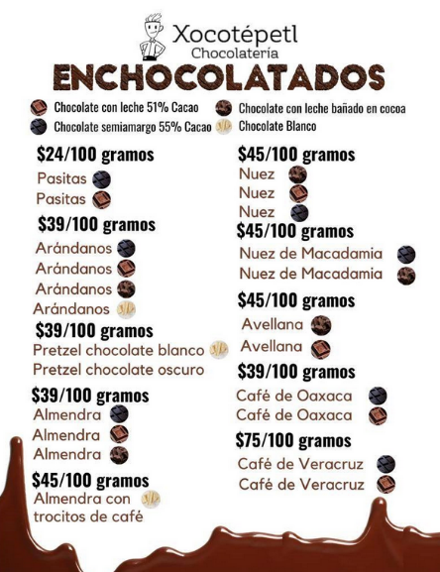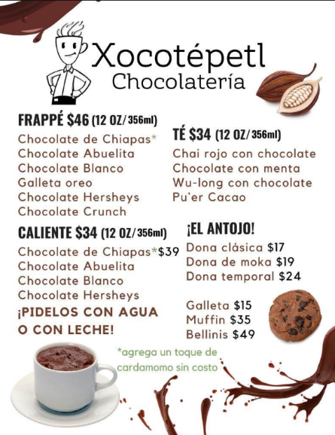

# Diseño del sistema

Ya una vez que tenemos lo anterior en cuenta, podemos pensar en una posible solución para el problema. Para el sistema a ejecutar, podríamos considerar las siguientes funcionalidades:

* Registro de ventas: el sistema debería permitir registrar las ventas de enchocolatados y bebidas, retornando un total.
* Consulta de inventario: el sistema debería consultar en cualquier momento el inventario.

En cuanto a los requerimientos específicos, podemos considerar lo siguiente:

* Registrar ventas con precio correcto: el sistema debería permitir ingresar el precio de venta de cada producto al momento de registrar la venta, para que el sistema pueda calcular el total de ingresos generados por esa venta.

La experiencia de usuario se podría mostrar de la siguiente manera.

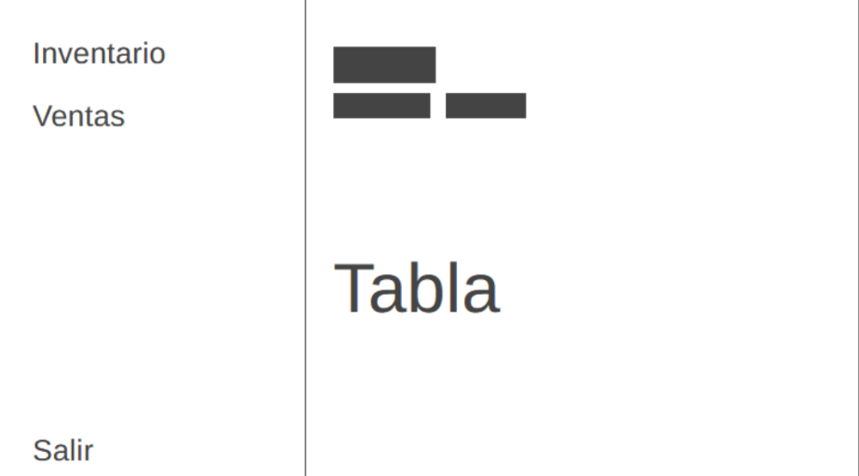

# Diagrama de la base de datos

El diagrama de la base de datos será el siguiente:

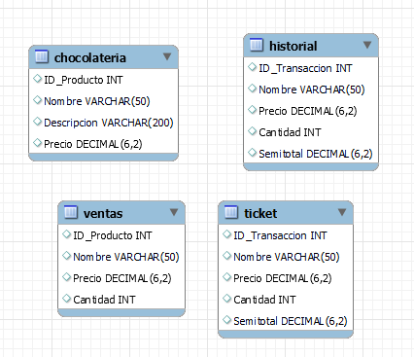

Las tablas que tendrá serán las siguientes:

## Tabla chocolateria

Esta tabla tendrá el inventario, y sus datos, algunos datos pueden variar de acuerdo con la tabla debido a las pruebas realizadas.

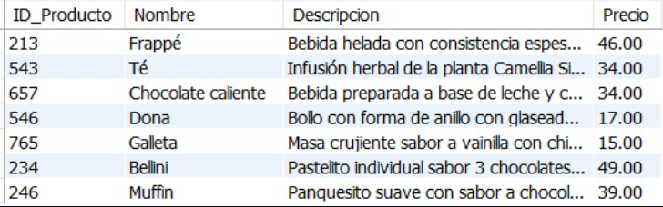

## Tabla ventas

Esta tabla tendrá las ventas al momento, y sus datos, algunos datos pueden variar de acuerdo con la tabla debido a las pruebas realizadas.

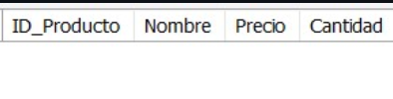

## Tabla ticket

Esta tabla tendrá las ventas al momento, y sus datos, algunos datos pueden variar de acuerdo con la tabla debido a las pruebas realizadas, esta es la tabla que se muestra al seleccionar carrito en el ticket.

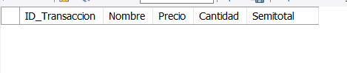

## Tabla historial

La tabla historial cuenta con todas las compras realizadas desde el momento en el que se implementó el sistema.

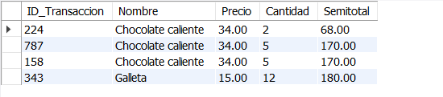

Esta tabla cuenta con datos debido a las pruebas realizadas.

# Código de base de datos

Ahora bien, el código fuente de la base de datos es el siguiente.

|  |
| --- |
| /*  Tabla principal  */  DROP TABLE IF EXISTS Chocolateria;  CREATE TABLE Chocolateria (  ID_Producto INT,  Nombre VARCHAR(50),  Descripcion VARCHAR(200),  Precio DECIMAL(6,2)  );  LOCK TABLES `Chocolateria` WRITE;  INSERT INTO `Chocolateria` (ID_Producto, Nombre, Descripcion, Precio) VALUES (213, 'Frappé', 'Bebida helada con consistencia espesa semejante a la de un helado.', 46.00);  INSERT INTO `Chocolateria` (ID_Producto, Nombre, Descripcion, Precio) VALUES (543, 'Té', 'Infusión herbal de la planta Camellia Sinensis, se puede preparar frío o caliente.', 34.00);  INSERT INTO `Chocolateria` (ID_Producto, Nombre, Descripcion, Precio) VALUES (657, 'Chocolate caliente', 'Bebida preparada a base de leche y chocolate blanco u oscuro.', 34.00);  INSERT INTO `Chocolateria` (ID_Producto, Nombre, Descripcion, Precio) VALUES (546, 'Dona', 'Bollo con forma de anillo con glaseado de glass, chocolate o maple.', 17.00);  INSERT INTO `Chocolateria` (ID_Producto, Nombre, Descripcion, Precio) VALUES (765, 'Galleta', 'Masa crujiente sabor a vainilla con chispas de chocolate belga o avena con pasas.', 15.00);  INSERT INTO `Chocolateria` (ID_Producto, Nombre, Descripcion, Precio) VALUES (234, 'Bellini', 'Pastelito individual sabor 3 chocolates sellado con mousse de chocolate.', 49.00);  INSERT INTO `Chocolateria` (ID_Producto, Nombre, Descripcion, Precio) VALUES (246, 'Muffin', 'Panquesito suave con sabor a chocolate con chispas o vainilla con mora azul.', 39.00);  UNLOCK TABLES;  /*  Tabla mientras se compra  */  DROP TABLE IF EXISTS Ventas;  CREATE TABLE Ventas (  ID_Producto INT,  Nombre VARCHAR(50),  Precio DECIMAL(6,2),  Cantidad INT  );  LOCK TABLES `ventas` WRITE;  UNLOCK TABLES;  /*  Tabla ticket  */  DROP TABLE IF EXISTS ticket;  CREATE TABLE ticket (  ID_Transaccion INT,  Nombre VARCHAR(50),  Precio DECIMAL(6,2),  Cantidad INT,  Semitotal DECIMAL(6,2)  );  LOCK TABLES `ticket` WRITE;  UNLOCK TABLES;  /*  Tabla de historial de ventas  */  DROP TABLE IF EXISTS historial;  CREATE TABLE historial (  ID_Transaccion INT,  Nombre VARCHAR(50),  Precio DECIMAL(6,2),  Cantidad INT,  Semitotal DECIMAL(6,2)  );  LOCK TABLES `historial` WRITE;  UNLOCK TABLES; |

# Limitaciones

Algunas de las limitaciones son las que cuenta el software son las siguientes:

* Dificultad para almacenar el stock, debido a que son bebidas preparadas, se hacen al momento, es decir no hay posibilidad de hacer el conteo sin los ingredientes.
* Dificultad para separar el historial de compras ya sea por compras o por fecha.

# Errores

El software tiene un error donde está la caja de cobro, al añadir o eliminar un objeto de la tabla salen muchos errores, pero esto no afecta al funcionamiento del sistema.

# Software

La clase principal se llama Xocotepetl.java

Para usar el software es necesario modificar la siguiente parte del código dentro de la clase Conexion_interac.

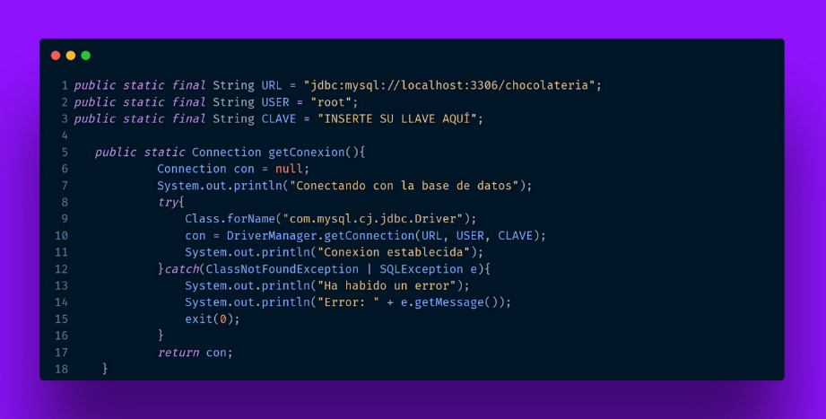

El apartado que se debe cambiar es donde dice INSERTE SU LLAVE AQUÍ.

El software además puede ser ejecutado descargando y configurando todo, para esto recomiendo usar.

* MySQL
* Apache NetBeans IDE 17
* Java: 19.0.2; Java HotSpot(TM) 64-Bit Server VM 19.0.2+7-44

A continuación, se muestra un ejemplo del uso del sistema, este sistema puede ser descargado y ejecutado como se mencionó anteriormente.

# Capturas

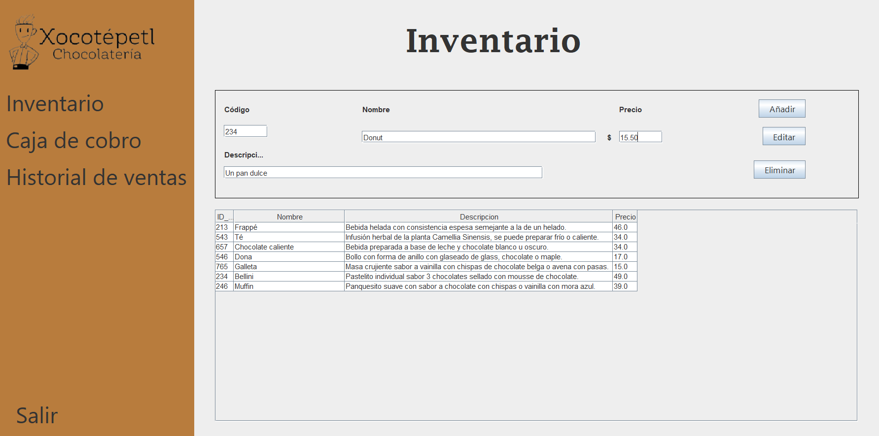

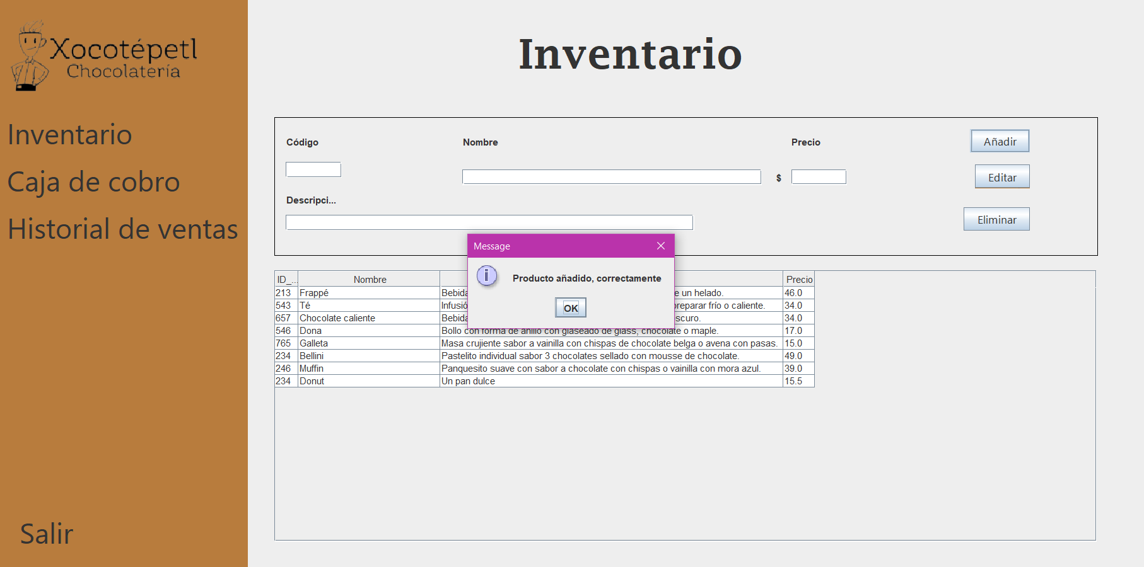

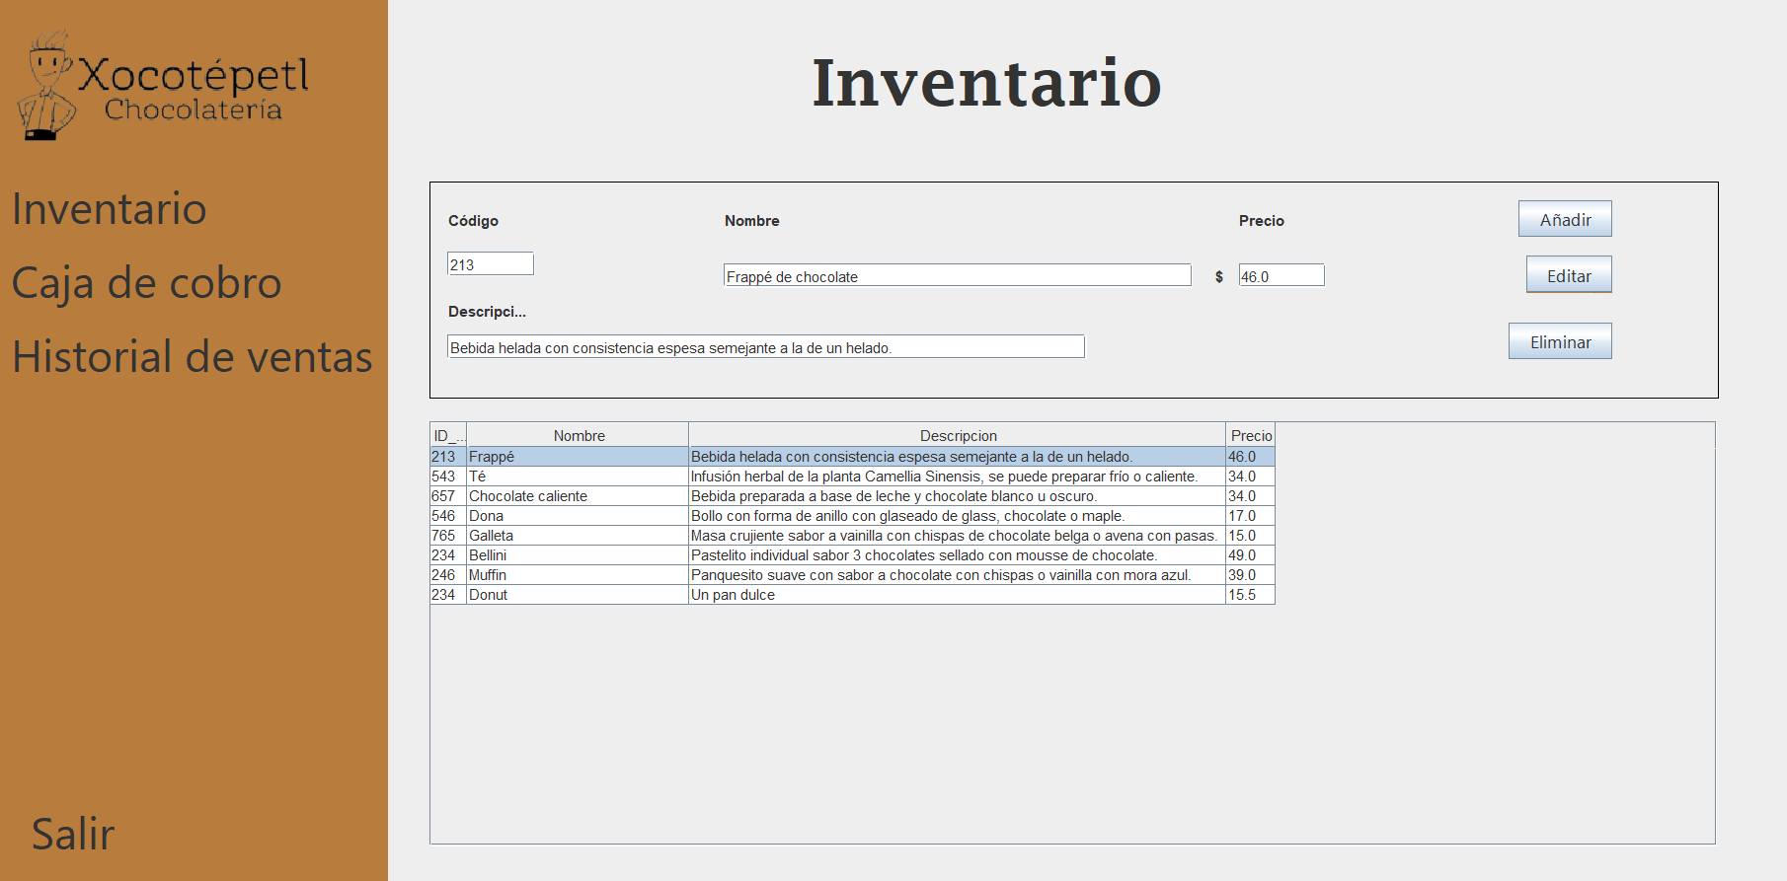

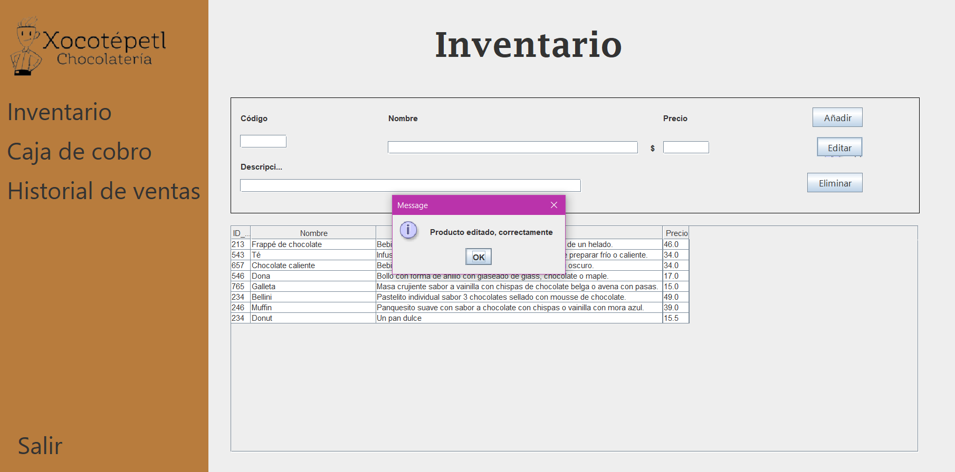

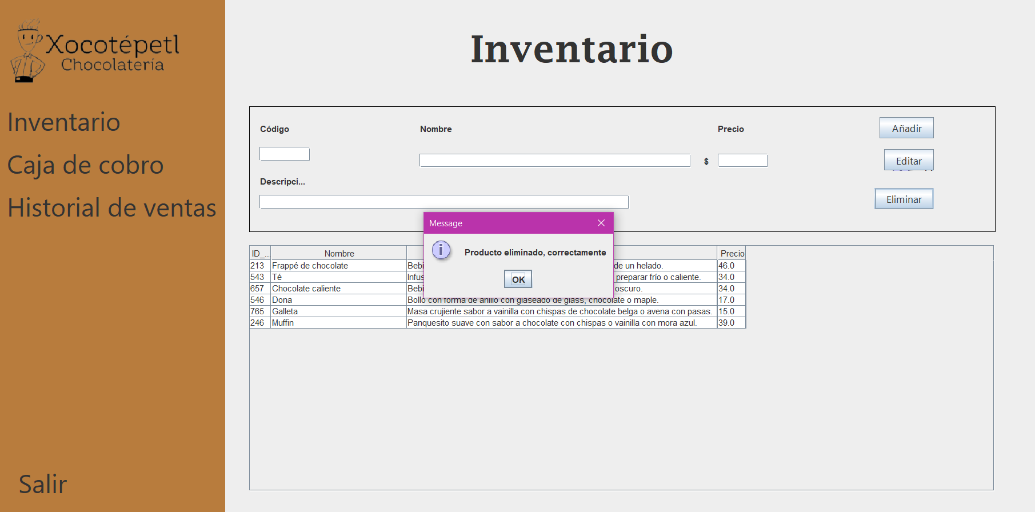

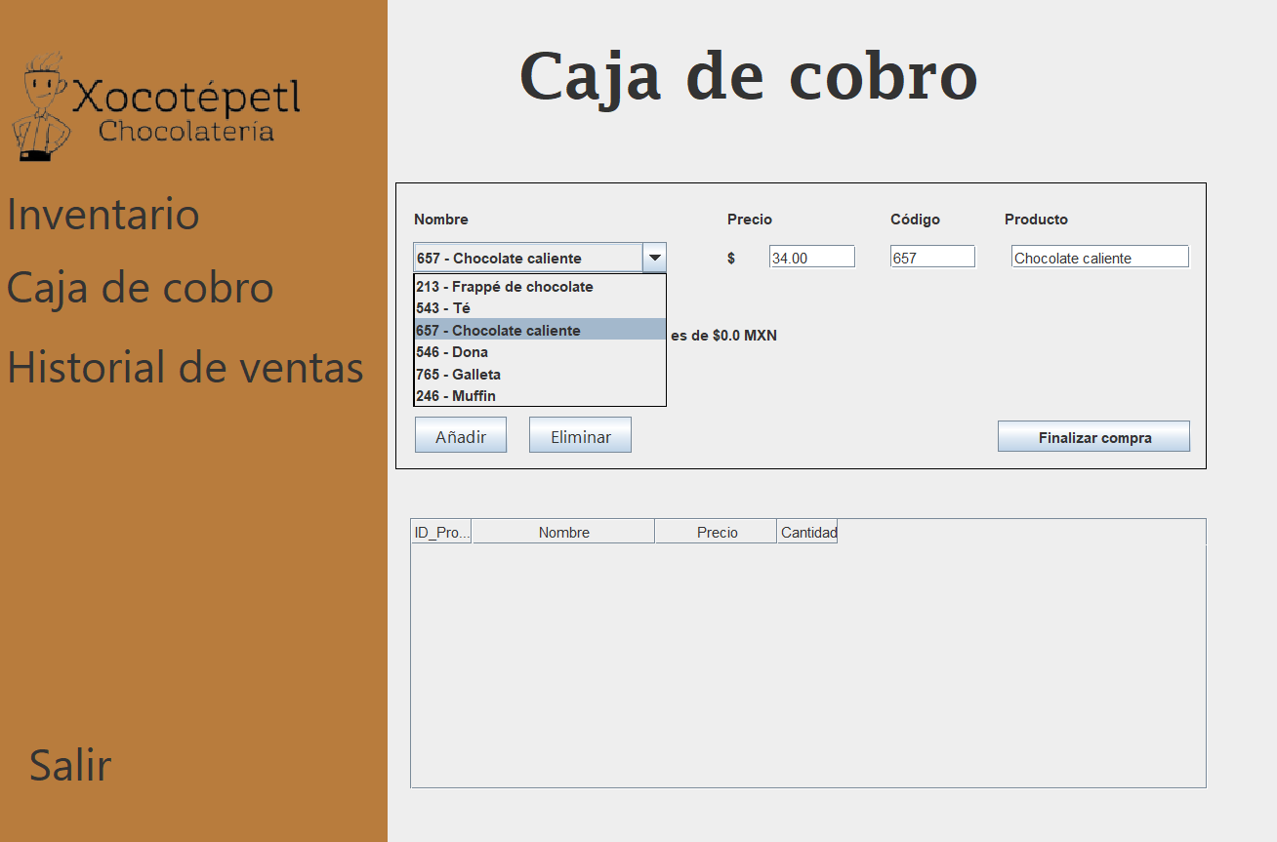

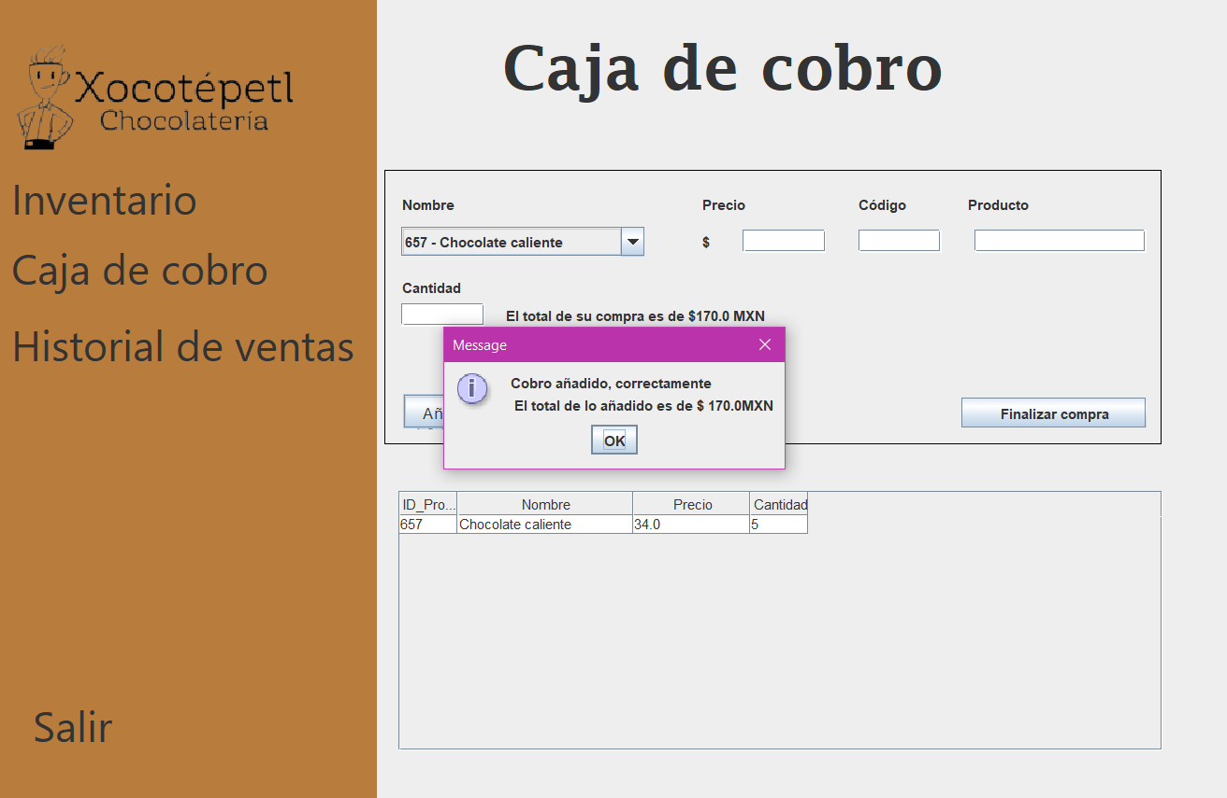

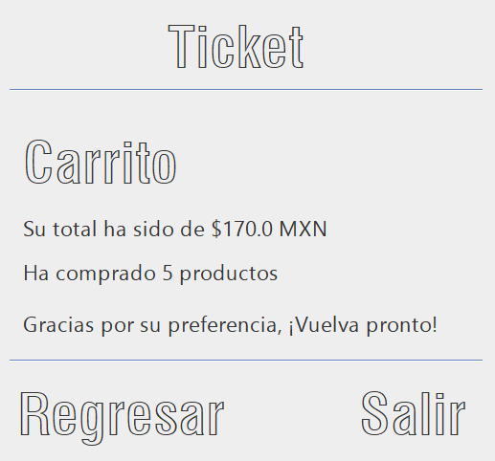

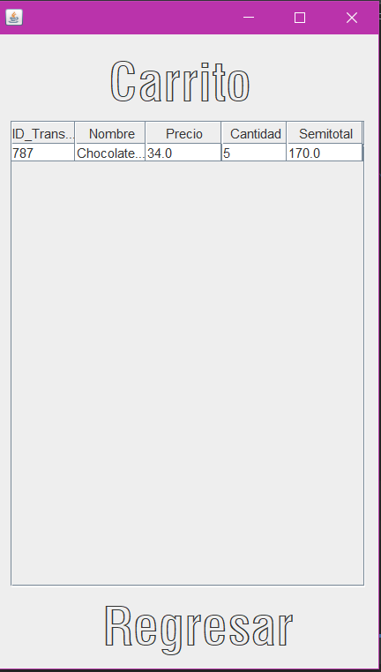

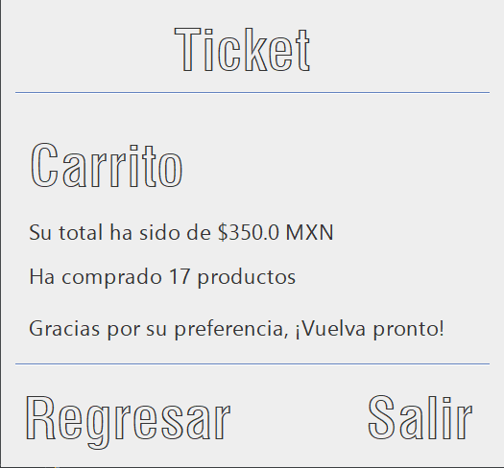

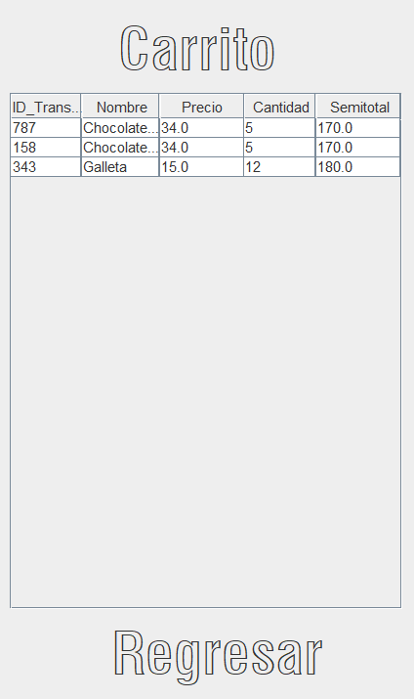

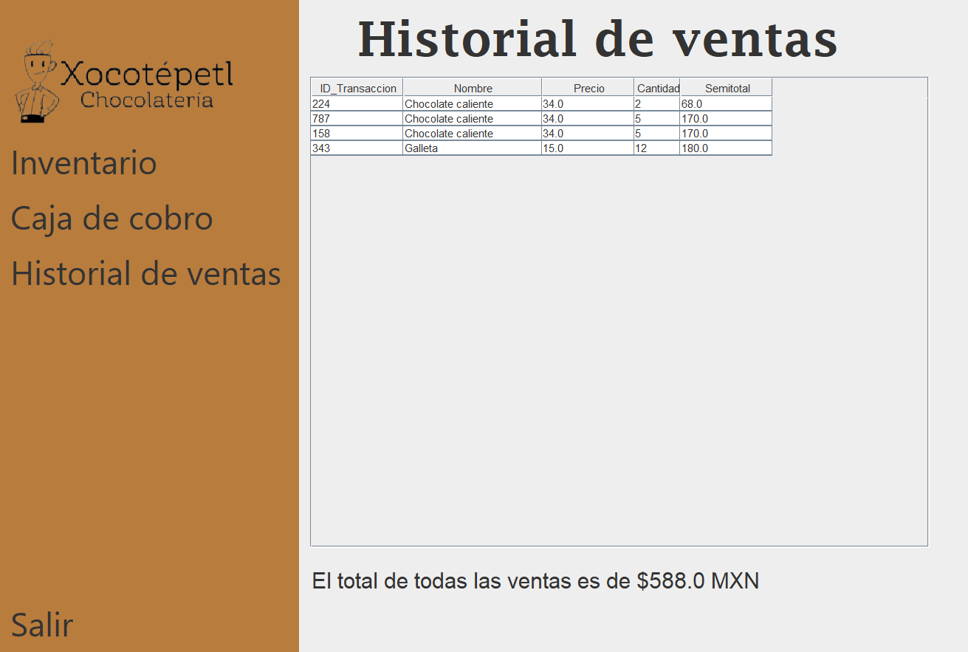

# Código fuente

El código fuente lo puede descargar a través del siguiente enlace.

<https://drive.google.com/file/d/19uYTlJSNGb5QfveDTWSAWq4ko8QXhG9H/view?usp=sharing>

Código fuente:

package xocotepetl;

import java.awt.Component;

import java.sql.Connection;

import java.sql.Statement;

import java.sql.ResultSet;

import java.sql.SQLException;

import java.sql.PreparedStatement;

import javax.swing.JOptionPane;

import javax.swing.JTable;

import javax.swing.table.DefaultTableModel;

import javax.swing.table.TableCellRenderer;

import javax.swing.table.TableColumn;

public class CajaDeCobro extends javax.swing.JFrame {

public CajaDeCobro() {

initComponents();

comboProducto();

mostrar();

lblsubtotal.setText("El total de su compra es de $" + calcularTotalVentas() + " MXN");

}

private void comboProducto(){

try {

Connection con = Conexion_interac.getConexion();

Statement st = con.createStatement();

ResultSet rs = st.executeQuery("SELECT ID_Producto, Nombre FROM chocolateria");

while (rs.next()) {

listadoProductos.addItem(rs.getString("ID_Producto") + " - " + rs.getString("Nombre"));

}

listadoProductos.setSelectedIndex(-1);

} catch (Exception e) {

System.out.println(e.getMessage());

}

codigoproducto.setText("");

productomostrado.setText("");

precioproducto.setText("");

}

private static double calcularTotalVentas() {

double totalVentas = 0.0;

try {

Connection con = Conexion_interac.getConexion();

Statement st = con.createStatement();

ResultSet rs = st.executeQuery("SELECT SUM(Cantidad * Precio) AS TotalVentas FROM ventas");

if (rs.next()) {

totalVentas = rs.getDouble("TotalVentas");

}

} catch (SQLException e) {

System.out.println(e);

}

return totalVentas;

}

private void mostrar() {

tablaventas.setAutoResizeMode(JTable.AUTO_RESIZE_OFF);

for (int column = 0; column < tablaventas.getColumnCount(); column++)

{

TableColumn tableColumn = tablaventas.getColumnModel().getColumn(column);

int preferredWidth = tableColumn.getMinWidth();

int maxWidth = tableColumn.getMaxWidth();

for (int row = 0; row < tablaventas.getRowCount(); row++)

{

TableCellRenderer cellRenderer = tablaventas.getCellRenderer(row, column);

Component c = tablaventas.prepareRenderer(cellRenderer, row, column);

int width = c.getPreferredSize().width + tablaventas.getIntercellSpacing().width;

preferredWidth = Math.max(preferredWidth, width);

if (preferredWidth >= maxWidth)

{

preferredWidth = maxWidth;

break;

}

}

tableColumn.setPreferredWidth(preferredWidth);

}

DefaultTableModel modelo = new DefaultTableModel();

modelo.setColumnIdentifiers(new String[]{"ID_Producto", "Nombre", "Precio", "Cantidad"});

try {

Connection con = Conexion_interac.getConexion();

Statement st = con.createStatement();

ResultSet rs = st.executeQuery("SELECT ID_Producto, Nombre, Precio, Cantidad FROM Ventas");

while (rs.next()) {

Object[] fila = new Object[4];

fila[0] = rs.getInt("ID_Producto");

fila[1] = rs.getString("Nombre");

fila[2] = rs.getDouble("Precio");

fila[3] = rs.getInt("Cantidad");

modelo.addRow(fila);

}

tablaventas.setModel(modelo);

tablaventas.getColumnModel().getColumn(0).setPreferredWidth(50);

tablaventas.getColumnModel().getColumn(1).setPreferredWidth(150);

tablaventas.getColumnModel().getColumn(2).setPreferredWidth(100);

tablaventas.getColumnModel().getColumn(3).setPreferredWidth(50);

} catch (Exception e) {

System.out.println(e);

}

}

@SuppressWarnings("unchecked")

// <editor-fold defaultstate="collapsed" desc="Generated Code">//GEN-BEGIN:initComponents

private void initComponents() {

jPanel1 = new javax.swing.JPanel();

jLabel1 = new javax.swing.JLabel();

jLabel2 = new javax.swing.JLabel();

jLabel4 = new javax.swing.JLabel();

imagen = new javax.swing.JLabel();

jLabel3 = new javax.swing.JLabel();

jLabel5 = new javax.swing.JLabel();

jLabel6 = new javax.swing.JLabel();

jPanel2 = new javax.swing.JPanel();

addproduct = new javax.swing.JButton();

rmvproduct = new javax.swing.JButton();

jLabel7 = new javax.swing.JLabel();

jLabel8 = new javax.swing.JLabel();

jLabel9 = new javax.swing.JLabel();

jLabel10 = new javax.swing.JLabel();

jLabel11 = new javax.swing.JLabel();

codigoproducto = new javax.swing.JTextField();

productomostrado = new javax.swing.JTextField();

jLabel13 = new javax.swing.JLabel();

cantidad = new javax.swing.JTextField();

listadoProductos = new javax.swing.JComboBox<>();

lblsubtotal = new javax.swing.JLabel();

cerrarcuenta = new javax.swing.JButton();

precioproducto = new javax.swing.JTextField();

jScrollPane1 = new javax.swing.JScrollPane();

tablaventas = new javax.swing.JTable();

setDefaultCloseOperation(javax.swing.WindowConstants.EXIT_ON_CLOSE);

setUndecorated(true);

jPanel1.setBackground(new java.awt.Color(184, 124, 61));

jLabel1.setFont(new java.awt.Font("Segoe UI", 0, 36)); // NOI18N

jLabel1.setText("Inventario");

jLabel1.addMouseListener(new java.awt.event.MouseAdapter() {

public void mouseClicked(java.awt.event.MouseEvent evt) {

jLabel1MouseClicked(evt);

}

});

jLabel2.setFont(new java.awt.Font("Segoe UI", 0, 36)); // NOI18N

jLabel2.setText("Salir");

jLabel2.addMouseListener(new java.awt.event.MouseAdapter() {

public void mouseClicked(java.awt.event.MouseEvent evt) {

jLabel2MouseClicked(evt);

}

public void mouseEntered(java.awt.event.MouseEvent evt) {

jLabel2MouseEntered(evt);

}

});

jLabel4.setFont(new java.awt.Font("Segoe UI", 0, 36)); // NOI18N

jLabel4.setText("Caja de cobro");

jLabel4.addMouseListener(new java.awt.event.MouseAdapter() {

public void mouseClicked(java.awt.event.MouseEvent evt) {

jLabel4MouseClicked(evt);

}

});

imagen.setIcon(new javax.swing.ImageIcon(getClass().getResource("/Imagen/logo.png"))); // NOI18N

jLabel3.setFont(new java.awt.Font("Segoe UI", 0, 36)); // NOI18N

jLabel3.setText("Historial de ventas");

jLabel3.addMouseListener(new java.awt.event.MouseAdapter() {

public void mouseClicked(java.awt.event.MouseEvent evt) {

jLabel3MouseClicked(evt);

}

});

javax.swing.GroupLayout jPanel1Layout = new javax.swing.GroupLayout(jPanel1);

jPanel1.setLayout(jPanel1Layout);

jPanel1Layout.setHorizontalGroup(

jPanel1Layout.createParallelGroup(javax.swing.GroupLayout.Alignment.LEADING)

.addGroup(jPanel1Layout.createSequentialGroup()

.addGroup(jPanel1Layout.createParallelGroup(javax.swing.GroupLayout.Alignment.LEADING)

.addGroup(jPanel1Layout.createSequentialGroup()

.addGap(30, 30, 30)

.addComponent(jLabel2, javax.swing.GroupLayout.PREFERRED_SIZE, 157, javax.swing.GroupLayout.PREFERRED_SIZE))

.addGroup(jPanel1Layout.createSequentialGroup()

.addContainerGap()

.addComponent(imagen, javax.swing.GroupLayout.PREFERRED_SIZE, 269, javax.swing.GroupLayout.PREFERRED_SIZE))

.addGroup(jPanel1Layout.createSequentialGroup()

.addContainerGap()

.addComponent(jLabel1, javax.swing.GroupLayout.PREFERRED_SIZE, 186, javax.swing.GroupLayout.PREFERRED_SIZE))

.addGroup(jPanel1Layout.createSequentialGroup()

.addContainerGap()

.addComponent(jLabel4, javax.swing.GroupLayout.PREFERRED_SIZE, 269, javax.swing.GroupLayout.PREFERRED_SIZE))

.addGroup(jPanel1Layout.createSequentialGroup()

.addContainerGap()

.addComponent(jLabel3)))

.addContainerGap(19, Short.MAX_VALUE))

);

jPanel1Layout.setVerticalGroup(

jPanel1Layout.createParallelGroup(javax.swing.GroupLayout.Alignment.LEADING)

.addGroup(jPanel1Layout.createSequentialGroup()

.addGap(34, 34, 34)

.addComponent(imagen, javax.swing.GroupLayout.PREFERRED_SIZE, 112, javax.swing.GroupLayout.PREFERRED_SIZE)

.addPreferredGap(javax.swing.LayoutStyle.ComponentPlacement.RELATED)

.addComponent(jLabel1)

.addPreferredGap(javax.swing.LayoutStyle.ComponentPlacement.UNRELATED)

.addComponent(jLabel4)

.addGap(18, 18, 18)

.addComponent(jLabel3)

.addPreferredGap(javax.swing.LayoutStyle.ComponentPlacement.RELATED, javax.swing.GroupLayout.DEFAULT_SIZE, Short.MAX_VALUE)

.addComponent(jLabel2)

.addGap(50, 50, 50))

);

jLabel5.setFont(new java.awt.Font("Lucida Fax", 1, 52)); // NOI18N

jLabel5.setHorizontalAlignment(javax.swing.SwingConstants.CENTER);

jLabel5.setText("Caja de cobro");

jPanel2.setBorder(javax.swing.BorderFactory.createLineBorder(new java.awt.Color(0, 0, 0)));

addproduct.setFont(new java.awt.Font("Segoe UI", 0, 14)); // NOI18N

addproduct.setText("Añadir");

addproduct.addActionListener(new java.awt.event.ActionListener() {

public void actionPerformed(java.awt.event.ActionEvent evt) {

addproductActionPerformed(evt);

}

});

rmvproduct.setFont(new java.awt.Font("Segoe UI", 0, 14)); // NOI18N

rmvproduct.setText("Eliminar");

rmvproduct.addActionListener(new java.awt.event.ActionListener() {

public void actionPerformed(java.awt.event.ActionEvent evt) {

rmvproductActionPerformed(evt);

}

});

jLabel7.setText("Código");

jLabel8.setText("Nombre");

jLabel9.setText("Precio");

jLabel10.setText("Producto");

jLabel11.setText("Cantidad");

codigoproducto.addActionListener(new java.awt.event.ActionListener() {

public void actionPerformed(java.awt.event.ActionEvent evt) {

codigoproductoActionPerformed(evt);

}

});

productomostrado.addActionListener(new java.awt.event.ActionListener() {

public void actionPerformed(java.awt.event.ActionEvent evt) {

productomostradoActionPerformed(evt);

}

});

jLabel13.setText("$");

cantidad.addInputMethodListener(new java.awt.event.InputMethodListener() {

public void caretPositionChanged(java.awt.event.InputMethodEvent evt) {

}

public void inputMethodTextChanged(java.awt.event.InputMethodEvent evt) {

cantidadInputMethodTextChanged(evt);

}

});

cantidad.addActionListener(new java.awt.event.ActionListener() {

public void actionPerformed(java.awt.event.ActionEvent evt) {

cantidadActionPerformed(evt);

}

});

listadoProductos.addItemListener(new java.awt.event.ItemListener() {

public void itemStateChanged(java.awt.event.ItemEvent evt) {

listadoProductosItemStateChanged(evt);

}

});

listadoProductos.addActionListener(new java.awt.event.ActionListener() {

public void actionPerformed(java.awt.event.ActionEvent evt) {

listadoProductosActionPerformed(evt);

}

});

lblsubtotal.setText("El total de su compra es de $0.0 MXN");

cerrarcuenta.setText("Finalizar compra");

cerrarcuenta.setToolTipText("");

cerrarcuenta.addActionListener(new java.awt.event.ActionListener() {

public void actionPerformed(java.awt.event.ActionEvent evt) {

cerrarcuentaActionPerformed(evt);

}

});

javax.swing.GroupLayout jPanel2Layout = new javax.swing.GroupLayout(jPanel2);

jPanel2.setLayout(jPanel2Layout);

jPanel2Layout.setHorizontalGroup(

jPanel2Layout.createParallelGroup(javax.swing.GroupLayout.Alignment.LEADING)

.addGroup(jPanel2Layout.createSequentialGroup()

.addGap(14, 14, 14)

.addGroup(jPanel2Layout.createParallelGroup(javax.swing.GroupLayout.Alignment.LEADING)

.addGroup(jPanel2Layout.createSequentialGroup()

.addComponent(cantidad, javax.swing.GroupLayout.PREFERRED_SIZE, 71, javax.swing.GroupLayout.PREFERRED_SIZE)

.addGap(18, 18, 18)

.addComponent(lblsubtotal, javax.swing.GroupLayout.PREFERRED_SIZE, 347, javax.swing.GroupLayout.PREFERRED_SIZE))

.addGroup(javax.swing.GroupLayout.Alignment.TRAILING, jPanel2Layout.createSequentialGroup()

.addGap(0, 0, Short.MAX_VALUE)

.addGroup(jPanel2Layout.createParallelGroup(javax.swing.GroupLayout.Alignment.LEADING)

.addGroup(javax.swing.GroupLayout.Alignment.TRAILING, jPanel2Layout.createSequentialGroup()

.addComponent(addproduct)

.addGap(18, 18, 18)

.addComponent(rmvproduct)

.addGap(300, 300, 300)

.addComponent(cerrarcuenta, javax.swing.GroupLayout.PREFERRED_SIZE, 158, javax.swing.GroupLayout.PREFERRED_SIZE))

.addGroup(javax.swing.GroupLayout.Alignment.TRAILING, jPanel2Layout.createSequentialGroup()

.addGroup(jPanel2Layout.createParallelGroup(javax.swing.GroupLayout.Alignment.LEADING)

.addGroup(javax.swing.GroupLayout.Alignment.TRAILING, jPanel2Layout.createSequentialGroup()

.addComponent(jLabel8, javax.swing.GroupLayout.PREFERRED_SIZE, 65, javax.swing.GroupLayout.PREFERRED_SIZE)

.addGap(192, 192, 192))

.addGroup(javax.swing.GroupLayout.Alignment.TRAILING, jPanel2Layout.createSequentialGroup()

.addGroup(jPanel2Layout.createParallelGroup(javax.swing.GroupLayout.Alignment.LEADING)

.addComponent(listadoProductos, javax.swing.GroupLayout.PREFERRED_SIZE, 208, javax.swing.GroupLayout.PREFERRED_SIZE)

.addComponent(jLabel11, javax.swing.GroupLayout.PREFERRED_SIZE, 79, javax.swing.GroupLayout.PREFERRED_SIZE))

.addGap(49, 49, 49)))

.addGroup(jPanel2Layout.createParallelGroup(javax.swing.GroupLayout.Alignment.LEADING)

.addComponent(jLabel9, javax.swing.GroupLayout.PREFERRED_SIZE, 65, javax.swing.GroupLayout.PREFERRED_SIZE)

.addGroup(jPanel2Layout.createSequentialGroup()

.addComponent(jLabel13, javax.swing.GroupLayout.PREFERRED_SIZE, 17, javax.swing.GroupLayout.PREFERRED_SIZE)

.addPreferredGap(javax.swing.LayoutStyle.ComponentPlacement.UNRELATED)

.addComponent(precioproducto, javax.swing.GroupLayout.PREFERRED_SIZE, 71, javax.swing.GroupLayout.PREFERRED_SIZE)))

.addGap(28, 28, 28)

.addGroup(jPanel2Layout.createParallelGroup(javax.swing.GroupLayout.Alignment.LEADING)

.addComponent(jLabel7, javax.swing.GroupLayout.PREFERRED_SIZE, 65, javax.swing.GroupLayout.PREFERRED_SIZE)

.addComponent(codigoproducto, javax.swing.GroupLayout.PREFERRED_SIZE, 71, javax.swing.GroupLayout.PREFERRED_SIZE))

.addGap(22, 22, 22)

.addGroup(jPanel2Layout.createParallelGroup(javax.swing.GroupLayout.Alignment.LEADING)

.addGroup(jPanel2Layout.createSequentialGroup()

.addGap(6, 6, 6)

.addComponent(productomostrado, javax.swing.GroupLayout.PREFERRED_SIZE, 147, javax.swing.GroupLayout.PREFERRED_SIZE))

.addComponent(jLabel10, javax.swing.GroupLayout.PREFERRED_SIZE, 65, javax.swing.GroupLayout.PREFERRED_SIZE))))))

.addContainerGap(javax.swing.GroupLayout.DEFAULT_SIZE, Short.MAX_VALUE))

);

jPanel2Layout.setVerticalGroup(

jPanel2Layout.createParallelGroup(javax.swing.GroupLayout.Alignment.LEADING)

.addGroup(jPanel2Layout.createSequentialGroup()

.addGap(20, 20, 20)

.addGroup(jPanel2Layout.createParallelGroup(javax.swing.GroupLayout.Alignment.BASELINE)

.addComponent(jLabel10)

.addComponent(jLabel8)

.addComponent(jLabel7)

.addComponent(jLabel9))

.addPreferredGap(javax.swing.LayoutStyle.ComponentPlacement.UNRELATED)

.addGroup(jPanel2Layout.createParallelGroup(javax.swing.GroupLayout.Alignment.BASELINE)

.addComponent(productomostrado, javax.swing.GroupLayout.PREFERRED_SIZE, javax.swing.GroupLayout.DEFAULT_SIZE, javax.swing.GroupLayout.PREFERRED_SIZE)

.addComponent(codigoproducto, javax.swing.GroupLayout.PREFERRED_SIZE, javax.swing.GroupLayout.DEFAULT_SIZE, javax.swing.GroupLayout.PREFERRED_SIZE)

.addComponent(listadoProductos, javax.swing.GroupLayout.PREFERRED_SIZE, javax.swing.GroupLayout.DEFAULT_SIZE, javax.swing.GroupLayout.PREFERRED_SIZE)

.addComponent(precioproducto, javax.swing.GroupLayout.PREFERRED_SIZE, javax.swing.GroupLayout.DEFAULT_SIZE, javax.swing.GroupLayout.PREFERRED_SIZE)

.addComponent(jLabel13))

.addGap(18, 18, 18)

.addComponent(jLabel11)

.addPreferredGap(javax.swing.LayoutStyle.ComponentPlacement.RELATED)

.addGroup(jPanel2Layout.createParallelGroup(javax.swing.GroupLayout.Alignment.BASELINE)

.addComponent(cantidad, javax.swing.GroupLayout.PREFERRED_SIZE, javax.swing.GroupLayout.DEFAULT_SIZE, javax.swing.GroupLayout.PREFERRED_SIZE)

.addComponent(lblsubtotal))

.addPreferredGap(javax.swing.LayoutStyle.ComponentPlacement.RELATED, 58, Short.MAX_VALUE)

.addGroup(jPanel2Layout.createParallelGroup(javax.swing.GroupLayout.Alignment.BASELINE)

.addComponent(addproduct)

.addComponent(rmvproduct)

.addComponent(cerrarcuenta))

.addContainerGap())

);

tablaventas.addMouseListener(new java.awt.event.MouseAdapter() {

public void mouseClicked(java.awt.event.MouseEvent evt) {

tablaventasMouseClicked(evt);

}

});

jScrollPane1.setViewportView(tablaventas);

javax.swing.GroupLayout layout = new javax.swing.GroupLayout(getContentPane());

getContentPane().setLayout(layout);

layout.setHorizontalGroup(

layout.createParallelGroup(javax.swing.GroupLayout.Alignment.LEADING)

.addGroup(layout.createSequentialGroup()

.addComponent(jPanel1, javax.swing.GroupLayout.PREFERRED_SIZE, javax.swing.GroupLayout.DEFAULT_SIZE, javax.swing.GroupLayout.PREFERRED_SIZE)

.addGroup(layout.createParallelGroup(javax.swing.GroupLayout.Alignment.LEADING)

.addGroup(layout.createParallelGroup(javax.swing.GroupLayout.Alignment.LEADING)

.addGroup(layout.createSequentialGroup()

.addGap(6, 6, 6)

.addComponent(jPanel2, javax.swing.GroupLayout.PREFERRED_SIZE, javax.swing.GroupLayout.DEFAULT_SIZE, javax.swing.GroupLayout.PREFERRED_SIZE)

.addPreferredGap(javax.swing.LayoutStyle.ComponentPlacement.RELATED)

.addComponent(jLabel6, javax.swing.GroupLayout.PREFERRED_SIZE, 37, javax.swing.GroupLayout.PREFERRED_SIZE))

.addGroup(javax.swing.GroupLayout.Alignment.TRAILING, layout.createSequentialGroup()

.addGap(35, 35, 35)

.addComponent(jLabel5, javax.swing.GroupLayout.PREFERRED_SIZE, 402, javax.swing.GroupLayout.PREFERRED_SIZE)

.addGap(223, 223, 223)))

.addGroup(layout.createSequentialGroup()

.addGap(18, 18, 18)

.addComponent(jScrollPane1, javax.swing.GroupLayout.PREFERRED_SIZE, 654, javax.swing.GroupLayout.PREFERRED_SIZE)))

.addContainerGap(javax.swing.GroupLayout.DEFAULT_SIZE, Short.MAX_VALUE))

);

layout.setVerticalGroup(

layout.createParallelGroup(javax.swing.GroupLayout.Alignment.LEADING)

.addGroup(layout.createSequentialGroup()

.addGap(33, 33, 33)

.addComponent(jLabel5)

.addGap(58, 58, 58)

.addComponent(jPanel2, javax.swing.GroupLayout.PREFERRED_SIZE, javax.swing.GroupLayout.DEFAULT_SIZE, javax.swing.GroupLayout.PREFERRED_SIZE)

.addPreferredGap(javax.swing.LayoutStyle.ComponentPlacement.RELATED)

.addComponent(jLabel6)

.addGap(34, 34, 34)

.addComponent(jScrollPane1, javax.swing.GroupLayout.PREFERRED_SIZE, 223, javax.swing.GroupLayout.PREFERRED_SIZE)

.addContainerGap(51, Short.MAX_VALUE))

.addComponent(jPanel1, javax.swing.GroupLayout.Alignment.TRAILING, javax.swing.GroupLayout.DEFAULT_SIZE, javax.swing.GroupLayout.DEFAULT_SIZE, Short.MAX_VALUE)

);

pack();

setLocationRelativeTo(null);

}// </editor-fold>//GEN-END:initComponents

private void addproductActionPerformed(java.awt.event.ActionEvent evt) {//GEN-FIRST:event_addproductActionPerformed

// TODO add your handling code here:

String vCodigoProducto = codigoproducto.getText();

String vIngredienteProducto = productomostrado.getText();

String vPrecio = precioproducto.getText();

String vCantidad = cantidad.getText();

int intcantidad = Integer.parseInt(vCantidad);

Double precio = Double.valueOf(vPrecio);

try {

Connection con = Conexion_interac.getConexion();

Statement st = con.createStatement();

st.execute("INSERT INTO ventas (ID_Producto, Nombre, Precio, Cantidad) "

+ "values(" + vCodigoProducto + ",'" + vIngredienteProducto + "', "

+ vPrecio + "," + vCantidad + ")");

codigoproducto.setText("");

productomostrado.setText("");

precioproducto.setText("");

cantidad.setText("");

mostrar();

lblsubtotal.setText("El total de su compra es de $" + calcularTotalVentas() + " MXN");

JOptionPane.showMessageDialog(null, "Cobro añadido, correctamente"

+ " \n El total de lo añadido es de $ " + intcantidad*precio + "MXN");

} catch (Exception e) {

System.out.println(e);

}

listadoProductos.setSelectedIndex(-1);

}//GEN-LAST:event_addproductActionPerformed

private void jLabel2MouseEntered(java.awt.event.MouseEvent evt) {//GEN-FIRST:event_jLabel2MouseEntered

}//GEN-LAST:event_jLabel2MouseEntered

private void jLabel2MouseClicked(java.awt.event.MouseEvent evt) {//GEN-FIRST:event_jLabel2MouseClicked

try {

Connection con = Conexion_interac.getConexion();

Statement st = con.createStatement();

ResultSet resultadoDeConteo = st.executeQuery("select count(*) as count from ventas");

resultadoDeConteo.next();

int count = resultadoDeConteo.getInt("count");

if (count > 0) {

st.executeUpdate("delete from ventas");

System.out.println(count + " registros eliminados de la tabla ventas.");

} else {

System.out.println("No existen registros en la tabla ventas.");

}

} catch (Exception e) {

System.out.println("\nAlgo ha fallado: " + e.getMessage());

}

System.exit(0);

}//GEN-LAST:event_jLabel2MouseClicked

private void jLabel4MouseClicked(java.awt.event.MouseEvent evt) {//GEN-FIRST:event_jLabel4MouseClicked

}//GEN-LAST:event_jLabel4MouseClicked

private void jLabel1MouseClicked(java.awt.event.MouseEvent evt) {//GEN-FIRST:event_jLabel1MouseClicked

Inventario inv = new Inventario();

this.hide();

inv.setVisible(true);

}//GEN-LAST:event_jLabel1MouseClicked

private void cantidadActionPerformed(java.awt.event.ActionEvent evt) {//GEN-FIRST:event_cantidadActionPerformed

}//GEN-LAST:event_cantidadActionPerformed

private void listadoProductosItemStateChanged(java.awt.event.ItemEvent evt) {//GEN-FIRST:event_listadoProductosItemStateChanged

}//GEN-LAST:event_listadoProductosItemStateChanged

private void listadoProductosActionPerformed(java.awt.event.ActionEvent evt) {//GEN-FIRST:event_listadoProductosActionPerformed

String selectedProduct = listadoProductos.getSelectedItem().toString();

String[] datosProducto = selectedProduct.split(" - ");

String selectedProductId = datosProducto[0];

try {

Connection con = Conexion_interac.getConexion();

Statement st = con.createStatement();

ResultSet rs = st.executeQuery("SELECT Precio FROM chocolateria WHERE ID_Producto = " + selectedProductId);

if (rs.next()) {

String precio = rs.getString("Precio");

precioproducto.setText(precio);

}

} catch (Exception e) {

System.out.println(e.getMessage());

}

codigoproducto.setText(datosProducto[0]);

productomostrado.setText(datosProducto[1]);

}//GEN-LAST:event_listadoProductosActionPerformed

private void rmvproductActionPerformed(java.awt.event.ActionEvent evt) {//GEN-FIRST:event_rmvproductActionPerformed

String vCodigoProducto = tablaventas.getValueAt(tablaventas.getSelectedRow(),0).toString();

String vIngredienteProducto = tablaventas.getValueAt(tablaventas.getSelectedRow(),1).toString();

String vPrecio = tablaventas.getValueAt(tablaventas.getSelectedRow(),2).toString();

try {

Connection con = Conexion_interac.getConexion();

Statement st = con.createStatement();

st.execute("DELETE FROM ventas WHERE ID_Producto = " + vCodigoProducto + " AND "

+ "Nombre = '" + vIngredienteProducto + "' AND "

+ "Precio = " + vPrecio);

mostrar();

lblsubtotal.setText("El total de su compra es de $" + calcularTotalVentas() + " MXN");

JOptionPane.showMessageDialog(null, "Cobro eliminado, correctamente");

} catch (Exception e) {

System.out.println(e);

}

listadoProductos.setSelectedIndex(-1);

}//GEN-LAST:event_rmvproductActionPerformed

private void cantidadInputMethodTextChanged(java.awt.event.InputMethodEvent evt) {//GEN-FIRST:event_cantidadInputMethodTextChanged

}//GEN-LAST:event_cantidadInputMethodTextChanged

private void productomostradoActionPerformed(java.awt.event.ActionEvent evt) {//GEN-FIRST:event_productomostradoActionPerformed

}//GEN-LAST:event_productomostradoActionPerformed

private void cerrarcuentaActionPerformed(java.awt.event.ActionEvent evt) {//GEN-FIRST:event_cerrarcuentaActionPerformed

Ticket ticket = new Ticket();

this.hide();

ticket.setVisible(true);

pasarDatosAVentas();

}//GEN-LAST:event_cerrarcuentaActionPerformed

private void pasarDatosAVentas() {

final String SELECT_VENTAS_QUERY = "SELECT Nombre, Precio, Cantidad FROM Ventas";

final String INSERT_TICKET_QUERY = "INSERT INTO ticket(ID_Transaccion, Nombre, Precio, Cantidad, Semitotal) VALUES (?, ?, ?, ?, ?)";

try (Connection con = Conexion_interac.getConexion();

Statement st = con.createStatement();

ResultSet rs = st.executeQuery(SELECT_VENTAS_QUERY);

PreparedStatement ps = con.prepareStatement(INSERT_TICKET_QUERY)) {

while (rs.next()) {

String nombre = rs.getString("Nombre");

double precio = rs.getDouble("Precio");

int cantidad = rs.getInt("Cantidad");

double semitotal = precio * cantidad;

int idTransaccion = (int) (Math.random() * 900) + 100;

ps.setInt(1, idTransaccion);

ps.setString(2, nombre);

ps.setDouble(3, precio);

ps.setInt(4, cantidad);

ps.setDouble(5, semitotal);

ps.addBatch();

}

int[] filasInsertadas = ps.executeBatch();

System.out.println("Filas insertadas en ticket: " + filasInsertadas.length);

} catch (SQLException e) {

System.out.println("Error al pasar datos a ventas: " + e.getMessage());

}

}

private void codigoproductoActionPerformed(java.awt.event.ActionEvent evt) {//GEN-FIRST:event_codigoproductoActionPerformed

}//GEN-LAST:event_codigoproductoActionPerformed

private void tablaventasMouseClicked(java.awt.event.MouseEvent evt) {//GEN-FIRST:event_tablaventasMouseClicked

if (evt.getClickCount() == 2) {

int vFilaSeleccionada = tablaventas.getSelectedRow();

codigoproducto.setText(tablaventas.getValueAt(vFilaSeleccionada, 0).toString());

productomostrado.setText(tablaventas.getValueAt(vFilaSeleccionada, 1).toString());

precioproducto.setText(tablaventas.getValueAt(vFilaSeleccionada, 2).toString());

cantidad.setText(tablaventas.getValueAt(vFilaSeleccionada, 3).toString());

}

}//GEN-LAST:event_tablaventasMouseClicked

private void jLabel3MouseClicked(java.awt.event.MouseEvent evt) {//GEN-FIRST:event_jLabel3MouseClicked

Historial_Ventas hv = new Historial_Ventas();

this.hide();

hv.setVisible(true);

}//GEN-LAST:event_jLabel3MouseClicked

public static void main(String args[]) {

java.awt.EventQueue.invokeLater(new Runnable() {

public void run() {

new CajaDeCobro().setVisible(true);

}

});

}

// Variables declaration - do not modify//GEN-BEGIN:variables

private javax.swing.JButton addproduct;

private javax.swing.JTextField cantidad;

private javax.swing.JButton cerrarcuenta;

private javax.swing.JTextField codigoproducto;

private javax.swing.JLabel imagen;

private javax.swing.JLabel jLabel1;

private javax.swing.JLabel jLabel10;

private javax.swing.JLabel jLabel11;

private javax.swing.JLabel jLabel13;

private javax.swing.JLabel jLabel2;

private javax.swing.JLabel jLabel3;

private javax.swing.JLabel jLabel4;

private javax.swing.JLabel jLabel5;

private javax.swing.JLabel jLabel6;

private javax.swing.JLabel jLabel7;

private javax.swing.JLabel jLabel8;

private javax.swing.JLabel jLabel9;

private javax.swing.JPanel jPanel1;

private javax.swing.JPanel jPanel2;

private javax.swing.JScrollPane jScrollPane1;

private javax.swing.JLabel lblsubtotal;

private javax.swing.JComboBox<String> listadoProductos;

private javax.swing.JTextField precioproducto;

private javax.swing.JTextField productomostrado;

private javax.swing.JButton rmvproduct;

private javax.swing.JTable tablaventas;

// End of variables declaration//GEN-END:variables

}

package xocotepetl;

import static java.lang.System.exit;

import java.sql.Connection;

import java.sql.DriverManager;

import java.sql.ResultSet;

import java.sql.SQLException;

import java.sql.Statement;

public class Conexion_interac {

public static final String DRIVER ="com.mysql.jdbc.Driver";

public static final String URL = "jdbc:mysql://localhost:3306/chocolateria";

public static final String USER = "root";

public static final String CLAVE = "D3PA$v&q34z5n";

public static Connection getConexion(){

Connection con = null;

System.out.println("Conectando con la base de datos");

try{

Class.forName("com.mysql.cj.jdbc.Driver");

con = DriverManager.getConnection(URL, USER, CLAVE);

System.out.println("Conexion establecida");

}catch(ClassNotFoundException | SQLException e){

System.out.println("Ha habido un error");

System.out.println("Error: " + e.getMessage());

exit(0);

}

return con;

}

public static ResultSet getTable(String consulta) {

Connection con = null;

Statement st;

ResultSet datos = null;

try {

con = getConexion();

st = con.createStatement();

datos = st.executeQuery(consulta);

System.out.println("Consulta de tabla buena");

} catch (SQLException e) {

System.out.println("Error: " + e.getMessage());

}

return datos;

}

}

package xocotepetl;

public class DatosInventario {

private int ID_Producto;

private String Nombre;

private float precio;

public DatosInventario(int ID_Producto, String Nombre, float precio) {

this.ID_Producto=ID_Producto;

this.Nombre = Nombre;

this.precio = precio;

}

public int getIDproducto() {

return ID_Producto;

}

public void setID_Producto(int ID_Producto) {

this.ID_Producto = ID_Producto;

}

public String getNombre() {

return Nombre;

}

public void setNombre(String Nombre) {

this.Nombre = Nombre;

}

public float getPrecio() {

return precio;

}

public void setPrecio(float precio) {

this.precio = precio;

}

}

package xocotepetl;

import java.sql.Connection;

import java.sql.Statement;

import java.sql.ResultSet;

import java.sql.SQLException;

import javax.swing.JTable;

import javax.swing.table.DefaultTableModel;

public class Historial_Ventas extends javax.swing.JFrame {

public Historial_Ventas() {

initComponents();

calcularTotalSemitotales();

mostrar();

lbltotalventas.setText("El total de todas las ventas es de $" + calcularTotalSemitotales() + " MXN");

}

private static double calcularTotalSemitotales() {

double totalSemitotales = 0.0;

try {

Connection con = Conexion_interac.getConexion();

Statement st = con.createStatement();

ResultSet rs = st.executeQuery("SELECT SUM(Semitotal) AS TotalSemitotales FROM historial");

if (rs.next()) {

totalSemitotales = rs.getDouble("TotalSemitotales");

}

} catch (SQLException e) {

System.out.println(e);

}

return totalSemitotales;

}

private void mostrar() {

tablahistorial.setAutoResizeMode(JTable.AUTO_RESIZE_OFF);

DefaultTableModel modelo = new DefaultTableModel();

modelo.setColumnIdentifiers(new String[]{"ID_Transaccion", "Nombre", "Precio", "Cantidad", "Semitotal"});

try {

Connection con = Conexion_interac.getConexion();

Statement st = con.createStatement();

ResultSet rs = st.executeQuery("SELECT ID_Transaccion, Nombre, Precio, Cantidad, Semitotal FROM historial");

while (rs.next()) {

Object[] fila = new Object[5];

fila[0] = rs.getInt("ID_Transaccion");

fila[1] = rs.getString("Nombre");

fila[2] = rs.getDouble("Precio");

fila[3] = rs.getInt("Cantidad");

fila[4] = rs.getDouble("Semitotal");

modelo.addRow(fila);

}

tablahistorial.setModel(modelo);

tablahistorial.getColumnModel().getColumn(0).setPreferredWidth(100);

tablahistorial.getColumnModel().getColumn(1).setPreferredWidth(150);

tablahistorial.getColumnModel().getColumn(2).setPreferredWidth(100);

tablahistorial.getColumnModel().getColumn(3).setPreferredWidth(50);

tablahistorial.getColumnModel().getColumn(4).setPreferredWidth(100);

} catch (Exception e) {

System.out.println(e);

}

}

@SuppressWarnings("unchecked")

// <editor-fold defaultstate="collapsed" desc="Generated Code">//GEN-BEGIN:initComponents

private void initComponents() {

jPanel1 = new javax.swing.JPanel();

jLabel1 = new javax.swing.JLabel();

jLabel2 = new javax.swing.JLabel();

jLabel4 = new javax.swing.JLabel();

imagen = new javax.swing.JLabel();

jLabel3 = new javax.swing.JLabel();

jLabel5 = new javax.swing.JLabel();

jLabel6 = new javax.swing.JLabel();

jScrollPane1 = new javax.swing.JScrollPane();

tablahistorial = new javax.swing.JTable();

lbltotalventas = new java.awt.Label();

setDefaultCloseOperation(javax.swing.WindowConstants.EXIT_ON_CLOSE);

setUndecorated(true);

jPanel1.setBackground(new java.awt.Color(184, 124, 61));

jLabel1.setFont(new java.awt.Font("Segoe UI", 0, 36)); // NOI18N

jLabel1.setText("Inventario");

jLabel1.addMouseListener(new java.awt.event.MouseAdapter() {

public void mouseClicked(java.awt.event.MouseEvent evt) {

jLabel1MouseClicked(evt);

}

});

jLabel2.setFont(new java.awt.Font("Segoe UI", 0, 36)); // NOI18N

jLabel2.setText("Salir");

jLabel2.addMouseListener(new java.awt.event.MouseAdapter() {

public void mouseClicked(java.awt.event.MouseEvent evt) {

jLabel2MouseClicked(evt);

}

public void mouseEntered(java.awt.event.MouseEvent evt) {

jLabel2MouseEntered(evt);

}

});

jLabel4.setFont(new java.awt.Font("Segoe UI", 0, 36)); // NOI18N

jLabel4.setText("Caja de cobro");

jLabel4.addMouseListener(new java.awt.event.MouseAdapter() {

public void mouseClicked(java.awt.event.MouseEvent evt) {

jLabel4MouseClicked(evt);

}

});

imagen.setIcon(new javax.swing.ImageIcon(getClass().getResource("/Imagen/logo.png"))); // NOI18N

jLabel3.setFont(new java.awt.Font("Segoe UI", 0, 36)); // NOI18N

jLabel3.setText("Historial de ventas");

javax.swing.GroupLayout jPanel1Layout = new javax.swing.GroupLayout(jPanel1);

jPanel1.setLayout(jPanel1Layout);

jPanel1Layout.setHorizontalGroup(

jPanel1Layout.createParallelGroup(javax.swing.GroupLayout.Alignment.LEADING)

.addGroup(jPanel1Layout.createSequentialGroup()

.addContainerGap()

.addGroup(jPanel1Layout.createParallelGroup(javax.swing.GroupLayout.Alignment.LEADING)

.addComponent(imagen, javax.swing.GroupLayout.PREFERRED_SIZE, 269, javax.swing.GroupLayout.PREFERRED_SIZE)

.addComponent(jLabel1, javax.swing.GroupLayout.PREFERRED_SIZE, 186, javax.swing.GroupLayout.PREFERRED_SIZE)

.addComponent(jLabel4, javax.swing.GroupLayout.PREFERRED_SIZE, 269, javax.swing.GroupLayout.PREFERRED_SIZE)

.addComponent(jLabel3)

.addComponent(jLabel2, javax.swing.GroupLayout.PREFERRED_SIZE, 157, javax.swing.GroupLayout.PREFERRED_SIZE))

.addContainerGap(19, Short.MAX_VALUE))

);

jPanel1Layout.setVerticalGroup(

jPanel1Layout.createParallelGroup(javax.swing.GroupLayout.Alignment.LEADING)

.addGroup(jPanel1Layout.createSequentialGroup()

.addGap(34, 34, 34)

.addComponent(imagen, javax.swing.GroupLayout.PREFERRED_SIZE, 112, javax.swing.GroupLayout.PREFERRED_SIZE)

.addPreferredGap(javax.swing.LayoutStyle.ComponentPlacement.RELATED)

.addComponent(jLabel1)

.addPreferredGap(javax.swing.LayoutStyle.ComponentPlacement.UNRELATED)

.addComponent(jLabel4)

.addPreferredGap(javax.swing.LayoutStyle.ComponentPlacement.UNRELATED)

.addComponent(jLabel3)

.addPreferredGap(javax.swing.LayoutStyle.ComponentPlacement.RELATED, javax.swing.GroupLayout.DEFAULT_SIZE, Short.MAX_VALUE)

.addComponent(jLabel2)

.addContainerGap())

);

jLabel5.setFont(new java.awt.Font("Lucida Fax", 1, 52)); // NOI18N

jLabel5.setHorizontalAlignment(javax.swing.SwingConstants.CENTER);

jLabel5.setText("Historial de ventas");

tablahistorial.addMouseListener(new java.awt.event.MouseAdapter() {

public void mouseClicked(java.awt.event.MouseEvent evt) {

tablahistorialMouseClicked(evt);

}

});

jScrollPane1.setViewportView(tablahistorial);

lbltotalventas.setFont(new java.awt.Font("Dialog", 0, 24)); // NOI18N

lbltotalventas.setText("El total de todas las ventas es de ");

javax.swing.GroupLayout layout = new javax.swing.GroupLayout(getContentPane());

getContentPane().setLayout(layout);

layout.setHorizontalGroup(

layout.createParallelGroup(javax.swing.GroupLayout.Alignment.LEADING)

.addGroup(layout.createSequentialGroup()

.addComponent(jPanel1, javax.swing.GroupLayout.PREFERRED_SIZE, javax.swing.GroupLayout.DEFAULT_SIZE, javax.swing.GroupLayout.PREFERRED_SIZE)

.addGroup(layout.createParallelGroup(javax.swing.GroupLayout.Alignment.LEADING)

.addGroup(layout.createSequentialGroup()

.addGap(47, 47, 47)

.addComponent(jLabel5, javax.swing.GroupLayout.PREFERRED_SIZE, 554, javax.swing.GroupLayout.PREFERRED_SIZE))

.addGroup(layout.createSequentialGroup()

.addPreferredGap(javax.swing.LayoutStyle.ComponentPlacement.UNRELATED)

.addGroup(layout.createParallelGroup(javax.swing.GroupLayout.Alignment.LEADING)

.addGroup(layout.createSequentialGroup()

.addComponent(lbltotalventas, javax.swing.GroupLayout.PREFERRED_SIZE, javax.swing.GroupLayout.DEFAULT_SIZE, javax.swing.GroupLayout.PREFERRED_SIZE)

.addGap(299, 299, 299)

.addComponent(jLabel6, javax.swing.GroupLayout.PREFERRED_SIZE, 37, javax.swing.GroupLayout.PREFERRED_SIZE))

.addComponent(jScrollPane1, javax.swing.GroupLayout.PREFERRED_SIZE, 671, javax.swing.GroupLayout.PREFERRED_SIZE))))

.addContainerGap(javax.swing.GroupLayout.DEFAULT_SIZE, Short.MAX_VALUE))

);

layout.setVerticalGroup(

layout.createParallelGroup(javax.swing.GroupLayout.Alignment.LEADING)

.addGroup(layout.createSequentialGroup()

.addContainerGap(javax.swing.GroupLayout.DEFAULT_SIZE, Short.MAX_VALUE)

.addComponent(jLabel5)

.addPreferredGap(javax.swing.LayoutStyle.ComponentPlacement.UNRELATED)

.addComponent(jScrollPane1, javax.swing.GroupLayout.PREFERRED_SIZE, 510, javax.swing.GroupLayout.PREFERRED_SIZE)

.addGap(18, 18, 18)

.addComponent(lbltotalventas, javax.swing.GroupLayout.PREFERRED_SIZE, javax.swing.GroupLayout.DEFAULT_SIZE, javax.swing.GroupLayout.PREFERRED_SIZE)

.addPreferredGap(javax.swing.LayoutStyle.ComponentPlacement.RELATED)

.addComponent(jLabel6)

.addGap(52, 52, 52))

.addComponent(jPanel1, javax.swing.GroupLayout.Alignment.TRAILING, javax.swing.GroupLayout.DEFAULT_SIZE, javax.swing.GroupLayout.DEFAULT_SIZE, Short.MAX_VALUE)

);

pack();

setLocationRelativeTo(null);

}// </editor-fold>//GEN-END:initComponents

private void jLabel2MouseEntered(java.awt.event.MouseEvent evt) {//GEN-FIRST:event_jLabel2MouseEntered

}//GEN-LAST:event_jLabel2MouseEntered

private void jLabel2MouseClicked(java.awt.event.MouseEvent evt) {//GEN-FIRST:event_jLabel2MouseClicked

try {

Connection con = Conexion_interac.getConexion();

Statement st = con.createStatement();

ResultSet resultadoDeConteo = st.executeQuery("select count(*) as count from ventas");

resultadoDeConteo.next();

int count = resultadoDeConteo.getInt("count");

if (count > 0) {

st.executeUpdate("delete from ventas");

System.out.println(count + " registros eliminados de la tabla ventas.");

} else {

System.out.println("No existen registros en la tabla ventas.");

}

} catch (Exception e) {

System.out.println("\nAlgo ha fallado: " + e.getMessage());

}

System.exit(0);

}//GEN-LAST:event_jLabel2MouseClicked

private void jLabel4MouseClicked(java.awt.event.MouseEvent evt) {//GEN-FIRST:event_jLabel4MouseClicked

CajaDeCobro cj = new CajaDeCobro();

this.hide();

cj.setVisible(true);

}//GEN-LAST:event_jLabel4MouseClicked

private void jLabel1MouseClicked(java.awt.event.MouseEvent evt) {//GEN-FIRST:event_jLabel1MouseClicked

// TODO add your handling code here:

Inventario inv = new Inventario();

this.hide();

inv.setVisible(true);

}//GEN-LAST:event_jLabel1MouseClicked

private void tablahistorialMouseClicked(java.awt.event.MouseEvent evt) {//GEN-FIRST:event_tablahistorialMouseClicked

}//GEN-LAST:event_tablahistorialMouseClicked

public static void main(String args[]) {

java.awt.EventQueue.invokeLater(new Runnable() {

public void run() {

new Historial_Ventas().setVisible(true);

}

});

}

// Variables declaration - do not modify//GEN-BEGIN:variables

private javax.swing.JLabel imagen;

private javax.swing.JLabel jLabel1;

private javax.swing.JLabel jLabel2;

private javax.swing.JLabel jLabel3;

private javax.swing.JLabel jLabel4;

private javax.swing.JLabel jLabel5;

private javax.swing.JLabel jLabel6;

private javax.swing.JPanel jPanel1;

private javax.swing.JScrollPane jScrollPane1;

private java.awt.Label lbltotalventas;

private javax.swing.JTable tablahistorial;

// End of variables declaration//GEN-END:variables

}

package xocotepetl;

import java.awt.Component;

import java.awt.HeadlessException;

import javax.swing.table.DefaultTableModel;

import java.sql.Connection;

import java.sql.ResultSet;

import java.sql.SQLException;

import java.sql.Statement;

import javax.swing.JOptionPane;

import javax.swing.JTable;

import javax.swing.table.TableCellRenderer;

import javax.swing.table.TableColumn;

public class Inventario extends javax.swing.JFrame {

Connection con;

public Inventario() {

this.con = Conexion_interac.getConexion();

System.out.println("Cargando tabla");

initComponents();

mostrar();

}

private void mostrar() {

tabla.setAutoResizeMode(JTable.AUTO_RESIZE_OFF);

for (int column = 0; column < tabla.getColumnCount(); column++)

{

TableColumn tableColumn = tabla.getColumnModel().getColumn(column);

int preferredWidth = tableColumn.getMinWidth();

int maxWidth = tableColumn.getMaxWidth();

for (int row = 0; row < tabla.getRowCount(); row++)

{

TableCellRenderer cellRenderer = tabla.getCellRenderer(row, column);

Component c = tabla.prepareRenderer(cellRenderer, row, column);

int width = c.getPreferredSize().width + tabla.getIntercellSpacing().width;

preferredWidth = Math.max(preferredWidth, width);

if (preferredWidth >= maxWidth)

{

preferredWidth = maxWidth;

break;

}

}

tableColumn.setPreferredWidth(preferredWidth);

}

DefaultTableModel modelo = new DefaultTableModel() {

@Override

public boolean isCellEditable(int row, int column) {

return false;

}

};

modelo.setColumnIdentifiers(new String[]{"ID_Producto", "Nombre", "Descripcion", "Precio"});

try {

Connection con = Conexion_interac.getConexion();

Statement st = con.createStatement();

ResultSet rs = st.executeQuery("SELECT ID_Producto, Nombre, Descripcion, Precio FROM chocolateria");

while (rs.next()) {

Productos filaProducto = new Productos(rs.getInt("ID_Producto"),rs.getString("Nombre"),rs.getString("Descripcion"), rs.getFloat("Precio"));

Object producto[] = {filaProducto.getIDproducto(),filaProducto.getNombre(),filaProducto.getDescripcion(),filaProducto.getPrecio()};

modelo.addRow(producto);

}

tabla.setModel(modelo);

int vAnchoColumna = 0;

int vNuevoAnchoColumna = 0;

for (int col = 0; col < tabla.getColumnCount(); col++) {

vAnchoColumna = 0;

for (int fila = 0; fila < tabla.getRowCount(); fila++) {

if (tabla.getValueAt(fila, col).toString().length() > 47) {

vNuevoAnchoColumna = 435;

} else {

vNuevoAnchoColumna = 10 * tabla.getValueAt(fila, col).toString().length();

}

if (vNuevoAnchoColumna>vAnchoColumna) {

vAnchoColumna = vNuevoAnchoColumna;

} else {

vAnchoColumna = vAnchoColumna;

}

}

tabla.getColumnModel().getColumn(col).setPreferredWidth(vAnchoColumna);

}

tabla.getColumnModel().getColumn(0).setMinWidth(30);

tabla.getColumnModel().getColumn(1).setMinWidth(45);

tabla.getColumnModel().getColumn(2).setMinWidth(60);

tabla.getColumnModel().getColumn(3).setMinWidth(30);

} catch (SQLException e) {

System.out.println(e);

}

}

@SuppressWarnings("unchecked")

// <editor-fold defaultstate="collapsed" desc="Generated Code">//GEN-BEGIN:initComponents

private void initComponents() {

jPanel1 = new javax.swing.JPanel();

jLabel1 = new javax.swing.JLabel();

jLabel2 = new javax.swing.JLabel();

jLabel4 = new javax.swing.JLabel();

imagen = new javax.swing.JLabel();

jLabel3 = new javax.swing.JLabel();

jLabel5 = new javax.swing.JLabel();

jLabel6 = new javax.swing.JLabel();

jPanel2 = new javax.swing.JPanel();

addproduct = new javax.swing.JButton();

rmvproduct = new javax.swing.JButton();

editproduct = new javax.swing.JButton();

jLabel8 = new javax.swing.JLabel();

jLabel9 = new javax.swing.JLabel();

jLabel10 = new javax.swing.JLabel();

nombreproducto = new javax.swing.JTextField();

descripcionproducto = new javax.swing.JTextField();

jLabel13 = new javax.swing.JLabel();

precio = new javax.swing.JTextField();

codepr = new javax.swing.JLabel();

ID_Productoin = new javax.swing.JTextField();

jScrollPane1 = new javax.swing.JScrollPane();

tabla = new javax.swing.JTable();

setDefaultCloseOperation(javax.swing.WindowConstants.EXIT_ON_CLOSE);

setUndecorated(true);

jPanel1.setBackground(new java.awt.Color(184, 124, 61));

jLabel1.setFont(new java.awt.Font("Segoe UI", 0, 36)); // NOI18N

jLabel1.setText("Inventario");

jLabel2.setFont(new java.awt.Font("Segoe UI", 0, 36)); // NOI18N

jLabel2.setText("Salir");

jLabel2.addMouseListener(new java.awt.event.MouseAdapter() {

public void mouseClicked(java.awt.event.MouseEvent evt) {

jLabel2MouseClicked(evt);

}

public void mouseEntered(java.awt.event.MouseEvent evt) {

jLabel2MouseEntered(evt);

}

});

jLabel4.setFont(new java.awt.Font("Segoe UI", 0, 36)); // NOI18N

jLabel4.setText("Caja de cobro");

jLabel4.addMouseListener(new java.awt.event.MouseAdapter() {

public void mouseClicked(java.awt.event.MouseEvent evt) {

jLabel4MouseClicked(evt);

}

});

imagen.setIcon(new javax.swing.ImageIcon(getClass().getResource("/Imagen/logo.png"))); // NOI18N

jLabel3.setFont(new java.awt.Font("Segoe UI", 0, 36)); // NOI18N

jLabel3.setText("Historial de ventas");

jLabel3.addMouseListener(new java.awt.event.MouseAdapter() {

public void mouseClicked(java.awt.event.MouseEvent evt) {

jLabel3MouseClicked(evt);

}

});

javax.swing.GroupLayout jPanel1Layout = new javax.swing.GroupLayout(jPanel1);

jPanel1.setLayout(jPanel1Layout);

jPanel1Layout.setHorizontalGroup(

jPanel1Layout.createParallelGroup(javax.swing.GroupLayout.Alignment.LEADING)

.addGroup(jPanel1Layout.createSequentialGroup()

.addContainerGap()

.addGroup(jPanel1Layout.createParallelGroup(javax.swing.GroupLayout.Alignment.LEADING)

.addGroup(jPanel1Layout.createSequentialGroup()

.addGroup(jPanel1Layout.createParallelGroup(javax.swing.GroupLayout.Alignment.LEADING)

.addComponent(jLabel4, javax.swing.GroupLayout.PREFERRED_SIZE, 239, javax.swing.GroupLayout.PREFERRED_SIZE)

.addComponent(jLabel1, javax.swing.GroupLayout.PREFERRED_SIZE, 179, javax.swing.GroupLayout.PREFERRED_SIZE)

.addGroup(jPanel1Layout.createSequentialGroup()

.addGap(16, 16, 16)

.addComponent(jLabel2, javax.swing.GroupLayout.PREFERRED_SIZE, 157, javax.swing.GroupLayout.PREFERRED_SIZE)))

.addGap(0, 0, Short.MAX_VALUE))

.addComponent(imagen, javax.swing.GroupLayout.Alignment.TRAILING, javax.swing.GroupLayout.DEFAULT_SIZE, javax.swing.GroupLayout.DEFAULT_SIZE, Short.MAX_VALUE)

.addGroup(javax.swing.GroupLayout.Alignment.TRAILING, jPanel1Layout.createSequentialGroup()

.addGap(0, 0, Short.MAX_VALUE)

.addComponent(jLabel3)))

.addContainerGap())

);

jPanel1Layout.setVerticalGroup(

jPanel1Layout.createParallelGroup(javax.swing.GroupLayout.Alignment.LEADING)

.addGroup(jPanel1Layout.createSequentialGroup()

.addGap(18, 18, 18)

.addComponent(imagen, javax.swing.GroupLayout.PREFERRED_SIZE, 112, javax.swing.GroupLayout.PREFERRED_SIZE)

.addGap(18, 18, 18)

.addComponent(jLabel1)

.addGap(12, 12, 12)

.addComponent(jLabel4)

.addPreferredGap(javax.swing.LayoutStyle.ComponentPlacement.UNRELATED)

.addComponent(jLabel3)

.addPreferredGap(javax.swing.LayoutStyle.ComponentPlacement.RELATED, 339, Short.MAX_VALUE)

.addComponent(jLabel2)

.addGap(25, 25, 25))

);

jLabel5.setFont(new java.awt.Font("Lucida Fax", 1, 52)); // NOI18N

jLabel5.setHorizontalAlignment(javax.swing.SwingConstants.CENTER);

jLabel5.setText("Inventario");

jPanel2.setBorder(javax.swing.BorderFactory.createLineBorder(new java.awt.Color(0, 0, 0)));

jPanel2.setToolTipText("Producto");

addproduct.setFont(new java.awt.Font("Segoe UI", 0, 14)); // NOI18N

addproduct.setText("Añadir");

addproduct.addActionListener(new java.awt.event.ActionListener() {

public void actionPerformed(java.awt.event.ActionEvent evt) {

addproductActionPerformed(evt);

}

});

rmvproduct.setFont(new java.awt.Font("Segoe UI", 0, 14)); // NOI18N

rmvproduct.setText("Eliminar");

rmvproduct.addActionListener(new java.awt.event.ActionListener() {

public void actionPerformed(java.awt.event.ActionEvent evt) {

rmvproductActionPerformed(evt);

}

});

editproduct.setFont(new java.awt.Font("Segoe UI", 0, 14)); // NOI18N

editproduct.setText("Editar");

editproduct.addActionListener(new java.awt.event.ActionListener() {

public void actionPerformed(java.awt.event.ActionEvent evt) {

editproductActionPerformed(evt);

}

});

jLabel8.setText("Nombre");

jLabel9.setText("Precio");

jLabel10.setText("Descripción");

nombreproducto.addActionListener(new java.awt.event.ActionListener() {

public void actionPerformed(java.awt.event.ActionEvent evt) {

nombreproductoActionPerformed(evt);

}

});

descripcionproducto.addActionListener(new java.awt.event.ActionListener() {

public void actionPerformed(java.awt.event.ActionEvent evt) {

descripcionproductoActionPerformed(evt);

}

});

jLabel13.setText("$");

codepr.setText("Código");

javax.swing.GroupLayout jPanel2Layout = new javax.swing.GroupLayout(jPanel2);

jPanel2.setLayout(jPanel2Layout);

jPanel2Layout.setHorizontalGroup(

jPanel2Layout.createParallelGroup(javax.swing.GroupLayout.Alignment.LEADING)

.addGroup(jPanel2Layout.createSequentialGroup()

.addGap(14, 14, 14)

.addGroup(jPanel2Layout.createParallelGroup(javax.swing.GroupLayout.Alignment.LEADING)

.addGroup(jPanel2Layout.createSequentialGroup()

.addComponent(descripcionproducto, javax.swing.GroupLayout.PREFERRED_SIZE, 518, javax.swing.GroupLayout.PREFERRED_SIZE)

.addPreferredGap(javax.swing.LayoutStyle.ComponentPlacement.RELATED, javax.swing.GroupLayout.DEFAULT_SIZE, Short.MAX_VALUE)

.addComponent(rmvproduct))

.addGroup(jPanel2Layout.createSequentialGroup()

.addGroup(jPanel2Layout.createParallelGroup(javax.swing.GroupLayout.Alignment.LEADING)

.addComponent(jLabel10, javax.swing.GroupLayout.PREFERRED_SIZE, 65, javax.swing.GroupLayout.PREFERRED_SIZE)

.addComponent(codepr, javax.swing.GroupLayout.PREFERRED_SIZE, 52, javax.swing.GroupLayout.PREFERRED_SIZE)

.addComponent(ID_Productoin, javax.swing.GroupLayout.PREFERRED_SIZE, 71, javax.swing.GroupLayout.PREFERRED_SIZE))

.addPreferredGap(javax.swing.LayoutStyle.ComponentPlacement.RELATED, 153, Short.MAX_VALUE)

.addGroup(jPanel2Layout.createParallelGroup(javax.swing.GroupLayout.Alignment.LEADING)

.addComponent(nombreproducto, javax.swing.GroupLayout.PREFERRED_SIZE, 380, javax.swing.GroupLayout.PREFERRED_SIZE)

.addComponent(jLabel8, javax.swing.GroupLayout.PREFERRED_SIZE, 65, javax.swing.GroupLayout.PREFERRED_SIZE))

.addGap(18, 18, 18)

.addComponent(jLabel13, javax.swing.GroupLayout.PREFERRED_SIZE, 17, javax.swing.GroupLayout.PREFERRED_SIZE)

.addGap(2, 2, 2)

.addGroup(jPanel2Layout.createParallelGroup(javax.swing.GroupLayout.Alignment.LEADING)

.addComponent(precio, javax.swing.GroupLayout.PREFERRED_SIZE, 71, javax.swing.GroupLayout.PREFERRED_SIZE)

.addComponent(jLabel9, javax.swing.GroupLayout.PREFERRED_SIZE, 65, javax.swing.GroupLayout.PREFERRED_SIZE))

.addGap(156, 156, 156)

.addGroup(jPanel2Layout.createParallelGroup(javax.swing.GroupLayout.Alignment.LEADING)

.addComponent(editproduct, javax.swing.GroupLayout.Alignment.TRAILING)

.addComponent(addproduct, javax.swing.GroupLayout.Alignment.TRAILING))))

.addGap(85, 85, 85))

);

jPanel2Layout.setVerticalGroup(

jPanel2Layout.createParallelGroup(javax.swing.GroupLayout.Alignment.LEADING)

.addGroup(jPanel2Layout.createSequentialGroup()

.addGap(14, 14, 14)

.addGroup(jPanel2Layout.createParallelGroup(javax.swing.GroupLayout.Alignment.BASELINE)

.addComponent(jLabel8)

.addComponent(jLabel9)

.addComponent(addproduct)

.addComponent(codepr))

.addGroup(jPanel2Layout.createParallelGroup(javax.swing.GroupLayout.Alignment.LEADING)

.addGroup(jPanel2Layout.createSequentialGroup()

.addGap(15, 15, 15)

.addGroup(jPanel2Layout.createParallelGroup(javax.swing.GroupLayout.Alignment.BASELINE)

.addComponent(nombreproducto, javax.swing.GroupLayout.PREFERRED_SIZE, javax.swing.GroupLayout.DEFAULT_SIZE, javax.swing.GroupLayout.PREFERRED_SIZE)

.addComponent(precio, javax.swing.GroupLayout.PREFERRED_SIZE, javax.swing.GroupLayout.DEFAULT_SIZE, javax.swing.GroupLayout.PREFERRED_SIZE)

.addComponent(jLabel13)

.addComponent(editproduct)))

.addGroup(jPanel2Layout.createSequentialGroup()

.addPreferredGap(javax.swing.LayoutStyle.ComponentPlacement.UNRELATED)

.addComponent(ID_Productoin, javax.swing.GroupLayout.PREFERRED_SIZE, javax.swing.GroupLayout.DEFAULT_SIZE, javax.swing.GroupLayout.PREFERRED_SIZE)))

.addPreferredGap(javax.swing.LayoutStyle.ComponentPlacement.RELATED)

.addGroup(jPanel2Layout.createParallelGroup(javax.swing.GroupLayout.Alignment.TRAILING)

.addGroup(jPanel2Layout.createSequentialGroup()

.addComponent(jLabel10)

.addPreferredGap(javax.swing.LayoutStyle.ComponentPlacement.UNRELATED)

.addComponent(descripcionproducto, javax.swing.GroupLayout.PREFERRED_SIZE, javax.swing.GroupLayout.DEFAULT_SIZE, javax.swing.GroupLayout.PREFERRED_SIZE))

.addComponent(rmvproduct))

.addContainerGap(31, Short.MAX_VALUE))

);

tabla.addMouseListener(new java.awt.event.MouseAdapter() {

public void mouseClicked(java.awt.event.MouseEvent evt) {

tablaMouseClicked(evt);

}

});

jScrollPane1.setViewportView(tabla);

javax.swing.GroupLayout layout = new javax.swing.GroupLayout(getContentPane());

getContentPane().setLayout(layout);

layout.setHorizontalGroup(

layout.createParallelGroup(javax.swing.GroupLayout.Alignment.LEADING)

.addGroup(layout.createSequentialGroup()

.addComponent(jPanel1, javax.swing.GroupLayout.PREFERRED_SIZE, javax.swing.GroupLayout.DEFAULT_SIZE, javax.swing.GroupLayout.PREFERRED_SIZE)

.addGroup(layout.createParallelGroup(javax.swing.GroupLayout.Alignment.LEADING)

.addGroup(layout.createSequentialGroup()

.addGap(33, 33, 33)

.addGroup(layout.createParallelGroup(javax.swing.GroupLayout.Alignment.LEADING)

.addGroup(layout.createSequentialGroup()

.addComponent(jScrollPane1, javax.swing.GroupLayout.PREFERRED_SIZE, 1044, javax.swing.GroupLayout.PREFERRED_SIZE)

.addPreferredGap(javax.swing.LayoutStyle.ComponentPlacement.RELATED)

.addComponent(jLabel6, javax.swing.GroupLayout.PREFERRED_SIZE, 37, javax.swing.GroupLayout.PREFERRED_SIZE))

.addComponent(jPanel2, javax.swing.GroupLayout.PREFERRED_SIZE, javax.swing.GroupLayout.DEFAULT_SIZE, javax.swing.GroupLayout.PREFERRED_SIZE)))

.addGroup(layout.createSequentialGroup()

.addGap(309, 309, 309)

.addComponent(jLabel5, javax.swing.GroupLayout.PREFERRED_SIZE, 353, javax.swing.GroupLayout.PREFERRED_SIZE)))

.addContainerGap(javax.swing.GroupLayout.DEFAULT_SIZE, Short.MAX_VALUE))

);

layout.setVerticalGroup(

layout.createParallelGroup(javax.swing.GroupLayout.Alignment.LEADING)

.addGroup(layout.createSequentialGroup()

.addGap(40, 40, 40)

.addComponent(jLabel5)

.addGap(51, 51, 51)

.addComponent(jPanel2, javax.swing.GroupLayout.PREFERRED_SIZE, javax.swing.GroupLayout.DEFAULT_SIZE, javax.swing.GroupLayout.PREFERRED_SIZE)

.addGroup(layout.createParallelGroup(javax.swing.GroupLayout.Alignment.LEADING)

.addGroup(layout.createSequentialGroup()

.addGap(63, 63, 63)

.addComponent(jLabel6))

.addGroup(layout.createSequentialGroup()

.addGap(18, 18, 18)

.addComponent(jScrollPane1, javax.swing.GroupLayout.PREFERRED_SIZE, 345, javax.swing.GroupLayout.PREFERRED_SIZE)))

.addContainerGap(javax.swing.GroupLayout.DEFAULT_SIZE, Short.MAX_VALUE))

.addGroup(layout.createSequentialGroup()

.addComponent(jPanel1, javax.swing.GroupLayout.PREFERRED_SIZE, javax.swing.GroupLayout.DEFAULT_SIZE, javax.swing.GroupLayout.PREFERRED_SIZE)

.addGap(0, 0, Short.MAX_VALUE))

);

pack();

setLocationRelativeTo(null);

}// </editor-fold>//GEN-END:initComponents

private void addproductActionPerformed(java.awt.event.ActionEvent evt) {//GEN-FIRST:event_addproductActionPerformed

String vID_Producto = ID_Productoin.getText();

String vNombreProducto = nombreproducto.getText();

String vDescripcionProducto = descripcionproducto.getText();

String vPrecio = precio.getText();

try {

Connection con = Conexion_interac.getConexion();

Statement st = con.createStatement();

st.execute("INSERT INTO `Chocolateria` (ID_Producto, Nombre, Descripcion, Precio) VALUES ("+ vID_Producto +",'"+ vNombreProducto + "','" + vDescripcionProducto +"', " + vPrecio +")");

ID_Productoin.setText("");

nombreproducto.setText("");

descripcionproducto.setText("");

precio.setText("");

mostrar();

JOptionPane.showMessageDialog(null, "Producto añadido, correctamente");

} catch (Exception e) {

System.out.println(e);

}

}//GEN-LAST:event_addproductActionPerformed

private void editproductActionPerformed(java.awt.event.ActionEvent evt) {//GEN-FIRST:event_editproductActionPerformed

String vID_Producto = ID_Productoin.getText();

String vNombreProducto = nombreproducto.getText();

String vDescripcionProducto = descripcionproducto.getText();

String vPrecio = precio.getText();

try {

Connection con = Conexion_interac.getConexion();

Statement st = con.createStatement();

st.execute("UPDATE chocolateria SET Nombre = '" + vNombreProducto + "', Descripcion = '" + vDescripcionProducto + "', Precio = " + vPrecio + " WHERE ID_Producto = " + vID_Producto );

ID_Productoin.setText("");

nombreproducto.setText("");

descripcionproducto.setText("");

precio.setText("");

mostrar();

JOptionPane.showMessageDialog(null, "Producto editado, correctamente");

} catch (HeadlessException | SQLException e) {

System.out.println(e);

}

}//GEN-LAST:event_editproductActionPerformed

private void descripcionproductoActionPerformed(java.awt.event.ActionEvent evt) {//GEN-FIRST:event_descripcionproductoActionPerformed

}//GEN-LAST:event_descripcionproductoActionPerformed

private void jLabel2MouseEntered(java.awt.event.MouseEvent evt) {//GEN-FIRST:event_jLabel2MouseEntered

}//GEN-LAST:event_jLabel2MouseEntered

private void jLabel2MouseClicked(java.awt.event.MouseEvent evt) {//GEN-FIRST:event_jLabel2MouseClicked

System.exit(0);

}//GEN-LAST:event_jLabel2MouseClicked

private void jLabel4MouseClicked(java.awt.event.MouseEvent evt) {//GEN-FIRST:event_jLabel4MouseClicked

CajaDeCobro cj = new CajaDeCobro();

this.hide();

cj.setVisible(true);

}//GEN-LAST:event_jLabel4MouseClicked

private void nombreproductoActionPerformed(java.awt.event.ActionEvent evt) {//GEN-FIRST:event_nombreproductoActionPerformed

String nombre = nombreproducto.getText();

System.out.println("El nombre del producto es \n"+nombre);

}//GEN-LAST:event_nombreproductoActionPerformed

private void tablaMouseClicked(java.awt.event.MouseEvent evt) {//GEN-FIRST:event_tablaMouseClicked

if (evt.getClickCount() == 2) {

int vFilaSeleccionada = tabla.getSelectedRow();

ID_Productoin.setText(tabla.getValueAt(vFilaSeleccionada, 0).toString());

nombreproducto.setText(tabla.getValueAt(vFilaSeleccionada, 1).toString());

descripcionproducto.setText(tabla.getValueAt(vFilaSeleccionada, 2).toString());

precio.setText(tabla.getValueAt(vFilaSeleccionada, 3).toString());

}

}//GEN-LAST:event_tablaMouseClicked

private void rmvproductActionPerformed(java.awt.event.ActionEvent evt) {//GEN-FIRST:event_rmvproductActionPerformed

try {

int vFilaSeleccionada = tabla.getSelectedRow();

Connection con = Conexion_interac.getConexion();

Statement st = con.createStatement();

st.execute("DELETE FROM `Chocolateria` WHERE ID_Producto = " + tabla.getValueAt(vFilaSeleccionada, 0));

ID_Productoin.setText("");

nombreproducto.setText("");

descripcionproducto.setText("");

precio.setText("");

mostrar();

JOptionPane.showMessageDialog(null, "Producto eliminado, correctamente");

System.out.println("\nSe ha borrado un producto exitosamenre \n");

} catch (Exception e) {

System.out.println(e);

}

}//GEN-LAST:event_rmvproductActionPerformed

private void jLabel3MouseClicked(java.awt.event.MouseEvent evt) {//GEN-FIRST:event_jLabel3MouseClicked

Historial_Ventas hv = new Historial_Ventas();

this.hide();

hv.setVisible(true);

}//GEN-LAST:event_jLabel3MouseClicked

public static void main(String args[]) {

java.awt.EventQueue.invokeLater(new Runnable() {

public void run() {

new Inventario().setVisible(true);

}

});

}

// Variables declaration - do not modify//GEN-BEGIN:variables

private javax.swing.JTextField ID_Productoin;

private javax.swing.JButton addproduct;

private javax.swing.JLabel codepr;

private javax.swing.JTextField descripcionproducto;

private javax.swing.JButton editproduct;

private javax.swing.JLabel imagen;

private javax.swing.JLabel jLabel1;

private javax.swing.JLabel jLabel10;

private javax.swing.JLabel jLabel13;

private javax.swing.JLabel jLabel2;

private javax.swing.JLabel jLabel3;

private javax.swing.JLabel jLabel4;

private javax.swing.JLabel jLabel5;

private javax.swing.JLabel jLabel6;

private javax.swing.JLabel jLabel8;

private javax.swing.JLabel jLabel9;

private javax.swing.JPanel jPanel1;

private javax.swing.JPanel jPanel2;

private javax.swing.JScrollPane jScrollPane1;

private javax.swing.JTextField nombreproducto;

private javax.swing.JTextField precio;

private javax.swing.JButton rmvproduct;

private javax.swing.JTable tabla;

// End of variables declaration//GEN-END:variables

}

package xocotepetl;

public class Productos extends DatosInventario {

private int ID_Producto;

private String Nombre;

private String descripcion;

private float precio;

public Productos( int ID_Producto, String Nombre, String descripcion, float precio) {

super( ID_Producto,Nombre, precio);

this.ID_Producto=ID_Producto;

this.Nombre = Nombre;

this.descripcion = descripcion;

this.precio = precio;

}

@Override

public int getIDproducto() {

return ID_Producto;

}

@Override

public void setID_Producto(int ID_Producto) {

this.ID_Producto = ID_Producto;

}

@Override

public String getNombre() {

return Nombre;

}

@Override

public void setNombre(String Nombre) {

this.Nombre = Nombre;

}

public void setDescripcion(String descripcion) {

this.descripcion = descripcion;

}

public String getDescripcion() {

return descripcion;

}

@Override

public float getPrecio() {

return precio;

}

@Override

public void setPrecio(float precio) {

this.precio = precio;

}

}

package xocotepetl;

import java.awt.Dimension;

import java.awt.Toolkit;

import java.sql.Connection;

import java.sql.Statement;

import java.sql.ResultSet;

import java.sql.SQLException;

import javax.swing.table.DefaultTableModel;

public class tabladelticket extends javax.swing.JFrame {

public tabladelticket() {

initComponents();

mostrarticket();

centrarPantalla();

}

private void centrarPantalla(){

Dimension pantalla = Toolkit.getDefaultToolkit().getScreenSize();

Dimension ventana = this.getSize();

int posX = (pantalla.width - ventana.width) /2;

int posY = (pantalla.height - ventana.height)/2;

this.setLocation(posX, posY);

}

public void mostrarticket() {

DefaultTableModel modelo = new DefaultTableModel() {

@Override

public boolean isCellEditable(int row, int column) {

return false;

}

};

modelo.setColumnIdentifiers(new String[]{"ID_Transaccion", "Nombre", "Precio", "Cantidad", "Semitotal"});

try {

Connection con = Conexion_interac.getConexion();

Statement st = con.createStatement();

ResultSet rs = st.executeQuery("SELECT ID_Transaccion, Nombre, Precio, Cantidad, Semitotal FROM ticket");

while (rs.next()) {

Object fila[] = new Object[5];

fila[0] = rs.getInt("ID_Transaccion");

fila[1] = rs.getString("Nombre");

fila[2] = rs.getDouble("Precio");

fila[3] = rs.getInt("Cantidad");

fila[4] = rs.getDouble("Semitotal");

modelo.addRow(fila);

}

tablaticket.setModel(modelo);

tablaticket.getColumnModel().getColumn(0).setMinWidth(30);

tablaticket.getColumnModel().getColumn(1).setMinWidth(45);

tablaticket.getColumnModel().getColumn(2).setMinWidth(60);

tablaticket.getColumnModel().getColumn(3).setMinWidth(30);

tablaticket.getColumnModel().getColumn(4).setMinWidth(60);

} catch (SQLException e) {

}

}

@SuppressWarnings("unchecked")

// <editor-fold defaultstate="collapsed" desc="Generated Code">//GEN-BEGIN:initComponents

private void initComponents() {

volver = new javax.swing.JLabel();

jScrollPane1 = new javax.swing.JScrollPane();

tablaticket = new javax.swing.JTable();

jLabel2 = new javax.swing.JLabel();

setDefaultCloseOperation(javax.swing.WindowConstants.EXIT_ON_CLOSE);

setUndecorated(true);

volver.setFont(new java.awt.Font("Swis721 BdCnOul BT", 0, 48)); // NOI18N

volver.setText("Regresar");

volver.addMouseListener(new java.awt.event.MouseAdapter() {

public void mouseClicked(java.awt.event.MouseEvent evt) {

boton(evt);

}

});

jScrollPane1.setViewportView(tablaticket);

jLabel2.setFont(new java.awt.Font("Swis721 BdCnOul BT", 0, 48)); // NOI18N

jLabel2.setText("Carrito");

javax.swing.GroupLayout layout = new javax.swing.GroupLayout(getContentPane());

getContentPane().setLayout(layout);

layout.setHorizontalGroup(

layout.createParallelGroup(javax.swing.GroupLayout.Alignment.LEADING)

.addGroup(layout.createSequentialGroup()

.addGroup(layout.createParallelGroup(javax.swing.GroupLayout.Alignment.LEADING)

.addGroup(layout.createSequentialGroup()

.addContainerGap()

.addComponent(jScrollPane1, javax.swing.GroupLayout.PREFERRED_SIZE, 322, javax.swing.GroupLayout.PREFERRED_SIZE))

.addGroup(layout.createSequentialGroup()

.addGap(101, 101, 101)

.addComponent(jLabel2)))

.addContainerGap(javax.swing.GroupLayout.DEFAULT_SIZE, Short.MAX_VALUE))

.addGroup(javax.swing.GroupLayout.Alignment.TRAILING, layout.createSequentialGroup()

.addGap(0, 0, Short.MAX_VALUE)

.addComponent(volver, javax.swing.GroupLayout.PREFERRED_SIZE, 195, javax.swing.GroupLayout.PREFERRED_SIZE)

.addGap(56, 56, 56))

);

layout.setVerticalGroup(

layout.createParallelGroup(javax.swing.GroupLayout.Alignment.LEADING)

.addGroup(layout.createSequentialGroup()

.addGap(14, 14, 14)

.addComponent(jLabel2)

.addPreferredGap(javax.swing.LayoutStyle.ComponentPlacement.RELATED)

.addComponent(jScrollPane1, javax.swing.GroupLayout.PREFERRED_SIZE, javax.swing.GroupLayout.DEFAULT_SIZE, javax.swing.GroupLayout.PREFERRED_SIZE)

.addPreferredGap(javax.swing.LayoutStyle.ComponentPlacement.RELATED)

.addComponent(volver)

.addContainerGap(29, Short.MAX_VALUE))

);

pack();

}// </editor-fold>//GEN-END:initComponents

private void boton(java.awt.event.MouseEvent evt) {//GEN-FIRST:event_boton

// TODO add your handling code here:

Ticket ticket = new Ticket();

this.hide();

ticket.setVisible(true);

}//GEN-LAST:event_boton

public static void main(String args[]) {

/* Set the Nimbus look and feel */

//<editor-fold defaultstate="collapsed" desc=" Look and feel setting code (optional) ">

/* If Nimbus (introduced in Java SE 6) is not available, stay with the default look and feel.

* For details see http://download.oracle.com/javase/tutorial/uiswing/lookandfeel/plaf.html

*/

try {

for (javax.swing.UIManager.LookAndFeelInfo info : javax.swing.UIManager.getInstalledLookAndFeels()) {

if ("Nimbus".equals(info.getName())) {

javax.swing.UIManager.setLookAndFeel(info.getClassName());

break;

}

}

} catch (ClassNotFoundException ex) {

java.util.logging.Logger.getLogger(tabladelticket.class.getName()).log(java.util.logging.Level.SEVERE, null, ex);

} catch (InstantiationException ex) {

java.util.logging.Logger.getLogger(tabladelticket.class.getName()).log(java.util.logging.Level.SEVERE, null, ex);

} catch (IllegalAccessException ex) {

java.util.logging.Logger.getLogger(tabladelticket.class.getName()).log(java.util.logging.Level.SEVERE, null, ex);

} catch (javax.swing.UnsupportedLookAndFeelException ex) {

java.util.logging.Logger.getLogger(tabladelticket.class.getName()).log(java.util.logging.Level.SEVERE, null, ex);

}

//</editor-fold>

/* Create and display the form */

java.awt.EventQueue.invokeLater(new Runnable() {

public void run() {

new tabladelticket().setVisible(true);

}

});

}

// Variables declaration - do not modify//GEN-BEGIN:variables

private javax.swing.JLabel jLabel2;

private javax.swing.JScrollPane jScrollPane1;

private javax.swing.JTable tablaticket;

private javax.swing.JLabel volver;

// End of variables declaration//GEN-END:variables

}

package xocotepetl;

import java.awt.Dimension;

import java.awt.Toolkit;

import java.sql.Connection;

import java.sql.Statement;

import java.sql.ResultSet;

import java.sql.SQLException;

import java.sql.PreparedStatement;

public final class Ticket extends javax.swing.JFrame {

public Ticket() {

initComponents();

centrarPantalla();

System.out.println("El total de ventas es: " + calcularTotalVentas() + "\nha comprado " +contarProductosVendidos());

lblPrecio.setText("Su total ha sido de $" + calcularTotalVentas() + " MXN");

lblProductosComprados.setText("\nHa comprado " + contarProductosVendidos() + " productos");

}

private void centrarPantalla(){

Dimension pantalla = Toolkit.getDefaultToolkit().getScreenSize();

Dimension ventana = this.getSize();

int posX = (pantalla.width - ventana.width) /2;

int posY = (pantalla.height - ventana.height)/2;

this.setLocation(posX, posY);

}

private static double calcularTotalVentas() {

double totalVentas = 0.0;

try {

Connection con = Conexion_interac.getConexion();

Statement st = con.createStatement();

ResultSet rs = st.executeQuery("SELECT SUM(Cantidad * Precio) AS TotalVentas FROM ventas");

if (rs.next()) {

totalVentas = rs.getDouble("TotalVentas");

}

} catch (SQLException e) {

System.out.println(e);

}

return totalVentas;

}

private static int contarProductosVendidos() {

int numProductosVendidos = 0;

try {

Connection con = Conexion_interac.getConexion();

Statement st = con.createStatement();

ResultSet rs = st.executeQuery("SELECT SUM(Cantidad) AS NumProductosVendidos FROM ventas");

if (rs.next()) {

numProductosVendidos = rs.getInt("NumProductosVendidos");

}

} catch (SQLException e) {

System.out.println(e);

}

return numProductosVendidos;

}

@SuppressWarnings("unchecked")

// <editor-fold defaultstate="collapsed" desc="Generated Code">//GEN-BEGIN:initComponents

private void initComponents() {

jScrollPane1 = new javax.swing.JScrollPane();

tablaventas = new javax.swing.JTable();

jLabel1 = new javax.swing.JLabel();

jSeparator1 = new javax.swing.JSeparator();

jLabel2 = new javax.swing.JLabel();

jSeparator2 = new javax.swing.JSeparator();

lblPrecio = new javax.swing.JLabel();

lblSalida = new javax.swing.JLabel();

lblProductosComprados = new javax.swing.JLabel();

jLabel3 = new javax.swing.JLabel();

jLabel4 = new javax.swing.JLabel();

tablaventas.addMouseListener(new java.awt.event.MouseAdapter() {

public void mouseClicked(java.awt.event.MouseEvent evt) {

tablaventasMouseClicked(evt);

}

});

jScrollPane1.setViewportView(tablaventas);

setTitle("Total");

setAlwaysOnTop(true);

setLocation(new java.awt.Point(0, 0));

setUndecorated(true);

jLabel1.setFont(new java.awt.Font("Swis721 BdCnOul BT", 0, 48)); // NOI18N

jLabel1.setText("Salir");

jLabel1.addMouseListener(new java.awt.event.MouseAdapter() {

public void mouseClicked(java.awt.event.MouseEvent evt) {

jLabel1MouseClicked(evt);

}

});

jLabel2.setFont(new java.awt.Font("Swis721 BdCnOul BT", 0, 48)); // NOI18N

jLabel2.setText("Ticket");

lblPrecio.setFont(new java.awt.Font("Segoe UI Historic", 0, 18)); // NOI18N

lblPrecio.setText("Costo");

lblSalida.setFont(new java.awt.Font("Segoe UI Historic", 0, 18)); // NOI18N

lblSalida.setText("Gracias por su preferencia, ¡Vuelva pronto!");

lblProductosComprados.setFont(new java.awt.Font("Segoe UI Historic", 0, 18)); // NOI18N

lblProductosComprados.setText("Total");

jLabel3.setFont(new java.awt.Font("Swis721 BdCnOul BT", 0, 48)); // NOI18N

jLabel3.setText("Regresar");

jLabel3.addMouseListener(new java.awt.event.MouseAdapter() {

public void mouseClicked(java.awt.event.MouseEvent evt) {

jLabel3MouseClicked(evt);

}

});

jLabel4.setFont(new java.awt.Font("Swis721 BdCnOul BT", 0, 48)); // NOI18N

jLabel4.setText("Carrito");

jLabel4.addMouseListener(new java.awt.event.MouseAdapter() {

public void mouseClicked(java.awt.event.MouseEvent evt) {

jLabel4MouseClicked(evt);

}

});

javax.swing.GroupLayout layout = new javax.swing.GroupLayout(getContentPane());

getContentPane().setLayout(layout);

layout.setHorizontalGroup(

layout.createParallelGroup(javax.swing.GroupLayout.Alignment.LEADING)

.addGroup(layout.createSequentialGroup()

.addGroup(layout.createParallelGroup(javax.swing.GroupLayout.Alignment.LEADING)

.addGroup(layout.createSequentialGroup()

.addContainerGap()

.addGroup(layout.createParallelGroup(javax.swing.GroupLayout.Alignment.LEADING)

.addComponent(jSeparator1, javax.swing.GroupLayout.PREFERRED_SIZE, 395, javax.swing.GroupLayout.PREFERRED_SIZE)

.addGroup(layout.createSequentialGroup()

.addGap(6, 6, 6)

.addComponent(jLabel3)

.addGap(112, 112, 112)

.addComponent(jLabel1))

.addComponent(jSeparator2, javax.swing.GroupLayout.PREFERRED_SIZE, 395, javax.swing.GroupLayout.PREFERRED_SIZE)

.addGroup(layout.createSequentialGroup()

.addGap(11, 11, 11)

.addGroup(layout.createParallelGroup(javax.swing.GroupLayout.Alignment.LEADING)

.addComponent(jLabel4)

.addGroup(layout.createParallelGroup(javax.swing.GroupLayout.Alignment.LEADING, false)

.addComponent(lblPrecio, javax.swing.GroupLayout.DEFAULT_SIZE, javax.swing.GroupLayout.DEFAULT_SIZE, Short.MAX_VALUE)

.addComponent(lblSalida, javax.swing.GroupLayout.DEFAULT_SIZE, 374, Short.MAX_VALUE)

.addComponent(lblProductosComprados, javax.swing.GroupLayout.DEFAULT_SIZE, javax.swing.GroupLayout.DEFAULT_SIZE, Short.MAX_VALUE))))))

.addGroup(layout.createSequentialGroup()

.addGap(144, 144, 144)

.addComponent(jLabel2)))

.addContainerGap(16, Short.MAX_VALUE))

);

layout.setVerticalGroup(

layout.createParallelGroup(javax.swing.GroupLayout.Alignment.LEADING)

.addGroup(layout.createSequentialGroup()

.addContainerGap()

.addComponent(jLabel2)

.addPreferredGap(javax.swing.LayoutStyle.ComponentPlacement.RELATED)

.addComponent(jSeparator1, javax.swing.GroupLayout.PREFERRED_SIZE, 10, javax.swing.GroupLayout.PREFERRED_SIZE)

.addPreferredGap(javax.swing.LayoutStyle.ComponentPlacement.RELATED, 22, Short.MAX_VALUE)

.addComponent(jLabel4)

.addPreferredGap(javax.swing.LayoutStyle.ComponentPlacement.UNRELATED)

.addComponent(lblPrecio)

.addPreferredGap(javax.swing.LayoutStyle.ComponentPlacement.UNRELATED)

.addComponent(lblProductosComprados)

.addGap(18, 18, 18)

.addComponent(lblSalida)

.addGap(18, 18, 18)

.addComponent(jSeparator2, javax.swing.GroupLayout.PREFERRED_SIZE, 10, javax.swing.GroupLayout.PREFERRED_SIZE)

.addPreferredGap(javax.swing.LayoutStyle.ComponentPlacement.RELATED)

.addGroup(layout.createParallelGroup(javax.swing.GroupLayout.Alignment.BASELINE)

.addComponent(jLabel3)

.addComponent(jLabel1))

.addContainerGap())

);

pack();

}// </editor-fold>//GEN-END:initComponents

private void jLabel1MouseClicked(java.awt.event.MouseEvent evt) {//GEN-FIRST:event_jLabel1MouseClicked

try {

pasarDatosAHistorial();

Connection con = Conexion_interac.getConexion();

Statement st = con.createStatement();

ResultSet resultadoDeConteo = st.executeQuery("select count(*) as count from ventas");

resultadoDeConteo.next();

int count = resultadoDeConteo.getInt("count");

if (count > 0) {

st.executeUpdate("delete from ventas");

System.out.println("\n"+count + " registros eliminados de la tabla ventas.");

try {

Connection con2 = Conexion_interac.getConexion();

Statement st2 = con2.createStatement();

st2.executeUpdate("DELETE FROM ticket"); // Eliminar todas las filas de la tabla "ticket"

System.out.println("Se eliminaron todos los datos de la tabla ticket.");

} catch (Exception e) {

System.out.println("Error al eliminar los datos de la tabla ticket: " + e.getMessage());

}

} else {

System.out.println("\nNo existen registros en la tabla ventas.");

}

} catch (Exception e) {

System.out.println("\nAlgo ha fallado: " + e.getMessage());

}

pasarDatosAHistorial();

System.exit(0);

}//GEN-LAST:event_jLabel1MouseClicked

private void pasarDatosAHistorial() {

final String SELECT_TICKET_QUERY = "SELECT ID_Transaccion, Nombre, Precio, Cantidad, Semitotal FROM ticket";

final String INSERT_HISTORIAL_QUERY = "INSERT INTO historial(ID_Transaccion, Nombre, Precio, Cantidad, Semitotal) VALUES (?, ?, ?, ?, ?)";

try (Connection con = Conexion_interac.getConexion();

Statement st = con.createStatement();

ResultSet rs = st.executeQuery(SELECT_TICKET_QUERY);

PreparedStatement ps = con.prepareStatement(INSERT_HISTORIAL_QUERY)) {

while (rs.next()) {

int idTransaccion = rs.getInt("ID_Transaccion");

String nombre = rs.getString("Nombre");

double precio = rs.getDouble("Precio");

int cantidad = rs.getInt("Cantidad");

double semitotal = rs.getDouble("Semitotal");

ps.setInt(1, idTransaccion);

ps.setString(2, nombre);

ps.setDouble(3, precio);

ps.setInt(4, cantidad);

ps.setDouble(5, semitotal);

ps.addBatch();

}

int[] filasInsertadas = ps.executeBatch();

System.out.println("Filas insertadas en historial: " + filasInsertadas.length);

} catch (SQLException e) {

System.out.println("Error al pasar datos a historial: " + e.getMessage());

}

}

private void jLabel3MouseClicked(java.awt.event.MouseEvent evt) {//GEN-FIRST:event_jLabel3MouseClicked

CajaDeCobro cj = new CajaDeCobro();

this.hide();

cj.setVisible(true);

try {

Connection con = Conexion_interac.getConexion();

Statement st = con.createStatement();

st.executeUpdate("DELETE FROM ticket"); // Eliminar todas las filas de la tabla "ticket"

System.out.println("Se eliminaron todos los datos de la tabla ticket.");

} catch (Exception e) {

System.out.println("Error al eliminar los datos de la tabla ticket: " + e.getMessage());

}

}//GEN-LAST:event_jLabel3MouseClicked

private void tablaventasMouseClicked(java.awt.event.MouseEvent evt) {//GEN-FIRST:event_tablaventasMouseClicked

}//GEN-LAST:event_tablaventasMouseClicked

private void jLabel4MouseClicked(java.awt.event.MouseEvent evt) {//GEN-FIRST:event_jLabel4MouseClicked

tabladelticket carrito = new tabladelticket();

this.hide();

carrito.setVisible(true);

}//GEN-LAST:event_jLabel4MouseClicked

public static void main(String args[]) {

try {

for (javax.swing.UIManager.LookAndFeelInfo info : javax.swing.UIManager.getInstalledLookAndFeels()) {

if ("Nimbus".equals(info.getName())) {

javax.swing.UIManager.setLookAndFeel(info.getClassName());

break;

}

}

} catch (ClassNotFoundException ex) {

java.util.logging.Logger.getLogger(Ticket.class.getName()).log(java.util.logging.Level.SEVERE, null, ex);

} catch (InstantiationException ex) {

java.util.logging.Logger.getLogger(Ticket.class.getName()).log(java.util.logging.Level.SEVERE, null, ex);

} catch (IllegalAccessException ex) {

java.util.logging.Logger.getLogger(Ticket.class.getName()).log(java.util.logging.Level.SEVERE, null, ex);

} catch (javax.swing.UnsupportedLookAndFeelException ex) {

java.util.logging.Logger.getLogger(Ticket.class.getName()).log(java.util.logging.Level.SEVERE, null, ex);

}

java.awt.EventQueue.invokeLater(() -> {

new Ticket().setVisible(true);

});

}

// Variables declaration - do not modify//GEN-BEGIN:variables

private javax.swing.JLabel jLabel1;

private javax.swing.JLabel jLabel2;

private javax.swing.JLabel jLabel3;

private javax.swing.JLabel jLabel4;

private javax.swing.JScrollPane jScrollPane1;

private javax.swing.JSeparator jSeparator1;

private javax.swing.JSeparator jSeparator2;

private javax.swing.JLabel lblPrecio;

private javax.swing.JLabel lblProductosComprados;

private javax.swing.JLabel lblSalida;

private javax.swing.JTable tablaventas;

// End of variables declaration//GEN-END:variables

}

package xocotepetl;

public class Xocotepetl {

public static void main(String[] args) {

Inventario in = new Inventario();

in.setVisible(true);

}

}